Document Exchange Installation
Conventions 2
Prerequisites 3
Installation 4
Installation checking and errors 6
Host Settings 10
Upgrading DMX 3 11
Uninstalling 13
Licensing and Activation 14
Upgrading 17
WebDAV 19
Css and Bootstrap 21

Conventions
DNN Platform (formerly DotNetNuke) is a CMS (Content Management System) built on Microsoft’s .Net framework. DNN Platform is referred to here as simply DNN. It is also referred to as the ‘framework’ or the ‘platform’ at times.
Document Exchange is a module for DNN. Document Exchange (Professional) is abbreviated to DMX. A module is an extension of the DNN framework and comes in the form of a zip file. The zip file includes a manifest (a file with the extension .dnn) that tells DNN how to install it.
If you are new to DNN and installing modules, I strongly urge you to familiarize yourself first with the platform and installing modules. DNN Corp (http://www.dnnsoftware.com) has excellent resources on this.

Prerequisites
- IIS
For WebDAV to function correctly you’ll need to be running on IIS 7 or above. You’ll also need access to the management panel of IIS.
- SQL 2008
DMX uses some features of SQL Server 2008. It will not work on SQL Server 2000.
- Minimal DNN version
DMX is compiled “against” a specific DNN platform version. The developers of DNN do their best to maintain backward compatibility so under normal circumstances you can assume that the module will run on any version up from the version used at compile time. As of this writing the dependency is DNN 8.0.0. This would mean DMX would also run on 9.0.2 for instance, but not on 7.4.2.

Installation
The installation of the module is similar to that of any module that is made for DNN. There are a number of things to keep in mind though, as well as an adjustment to IIS that is required to enable WebDAV. Whether you’re installing DMX for the first time into your installation or you’re upgrading an older version, the procedure is the same:
- Make a backup of your DNN installation and database. This is especially important if you’re upgrading an older version of DMX.
- Verify your web.config (see note below) for potential timeout issue
- Log in as host on your DNN installation
- Go to ‘Extensions’ under the host menu (Extensions on the Settings part of the PersonaBar in DNN 9+)
- Select ‘Install Extension (Wizard)’
- Browse to and select the Bring2mind.DMX.xx.yy.zz.zip and click upload
- Walk through the wizard steps to install the module. Note that during this time the following is happening:
- The zip file (around 1.5 Mb) is uploaded to the installation
- The contents are checked, the manifest file is extracted and examined
- Necessary SQL scripts are run
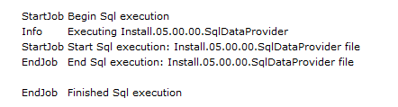
- Files are copied into place
- The module is registered in the installation
The above can easily take a couple of minutes. Take this into account.
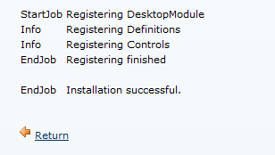
- The web page you’re looking at should show you an installation report. Scroll down this report to check if there are any red text blocks signifying there were errors during install. If there were continue reading the ‘Installation Checking and Errors’ section below.
When no errors have shown up you have installed the module into the DNN installation.
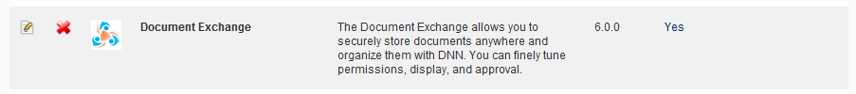
You’ll need to be aware of the following:
During the installation/upgrade the module will make some changes to the web.config. When uninstalling the module these changes have to be undone or your whole DNN installation will refuse to work. Check the uninstall procedure for this.

Important
You need to be aware of the fact that DNN does not provide complete roll-back functions if something goes wrong. This is jargon for: if something goes wrong during installation it can leave your DNN in a mess. Best practice is to make a backup of your DNN before you install new modules (or upgrade). If you are a DNN expert you probably know enough about the installation process to recover a bad install, but if you’re not comfortable please back up.
Regardless if you’re an expert or not, during upgrades of DMX you should back up. This is because a failed upgrade cannot be undone and you risk losing existing data. So if your data is precious to you, back up your DNN before doing upgrades.

Installation checking and errors
There are a number of things you can do to determine to what degree the installation has succeeded.
- On the server use the Explorer to go the directory where DNN is installed and check that underneath that you find DesktopModules\Bring2mind\DMX. This is the installation directory of various controls that this module uses. If this is absent then the installation is critically flawed. Verify that the ASP.NET worker process (by default ‘NETWORK SERVICE’ under IIS6) has sufficient rights to create directories and files in this location.
- In the DesktopModules\Bring2mind\DMX folder there should be a sub folder called ‘Resources’. If not then it looks like a failed upgrade of DMX 3 to 4/5. Again check the file permissions as mentioned above.
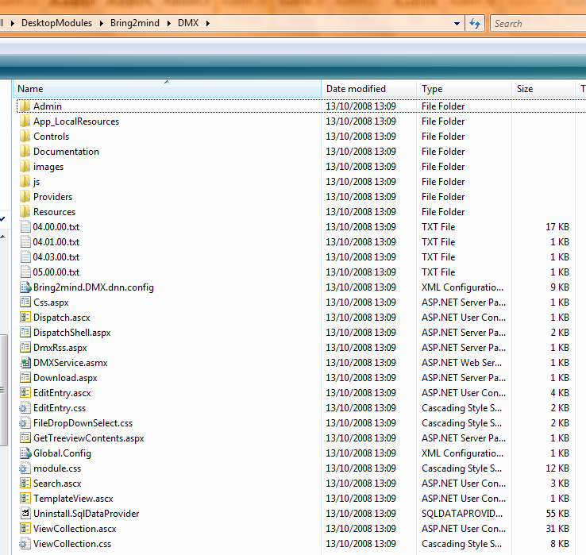
- Open your SQL Server Management Studio and open the database that your DNN installation uses (exact procedure might vary according to your Windows/SQL/DNN setup). Verify that there are a bunch of tables and stored procedures that begin with DMX_ (prefix with any object qualifier you’ve defined in your web.config). If there are none, then the whole data layer is missing. If you do not find the table DMX_Permissions but you do find DMX_Entries then it looks like a failed upgrade of DMX 3 to 4/5. In any case the error is critical. Check that in our web.config you’ve set the SQL connection string correctly in both connectionStrings and under appSettings. Also verify the SqlDataProvider section in the web.config.
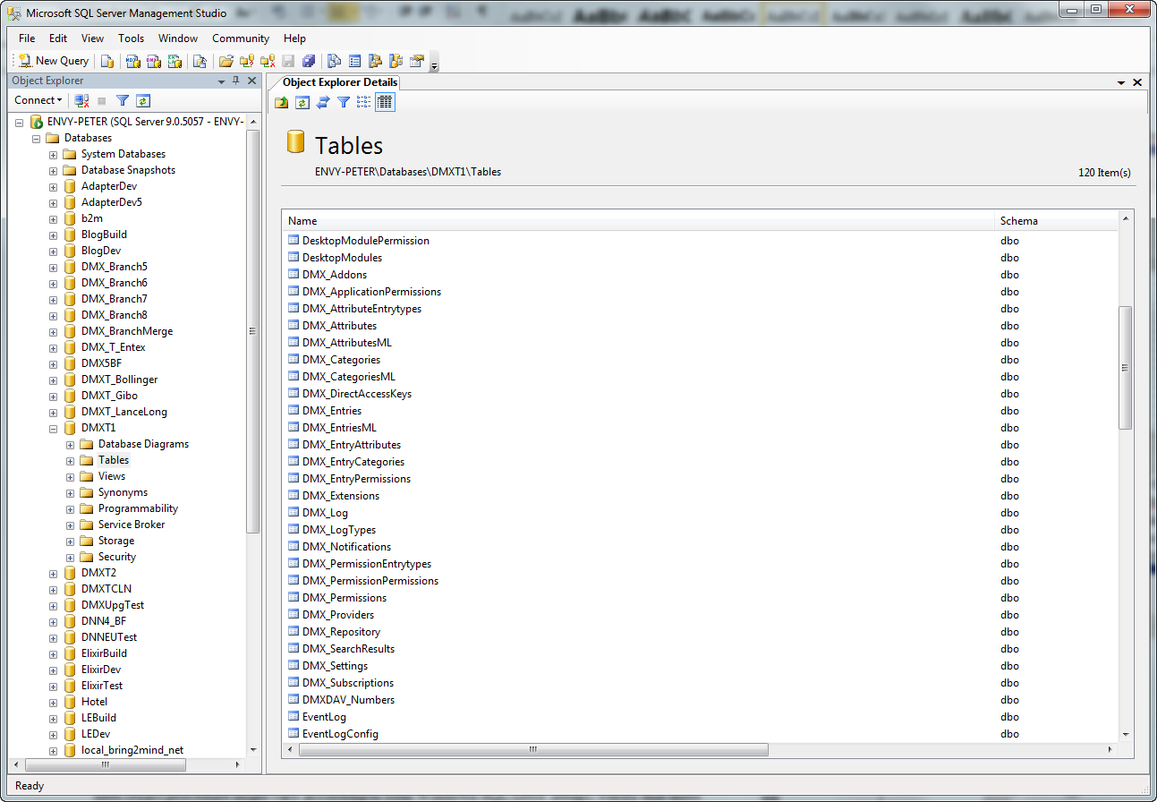
- Open the DesktopModules table and verify there is a record where the ‘FriendlyName’ is ‘Document Exchange’. In ModuleDefinitions check there is a record where ‘FriendlyName’ is ‘Bring2mind\DMX’. Make a mental note of the ModuleDefId. Check the ModuleControls table to see there are a bunch of records that have this ModuleDefId. If any of this doesn’t check out the module is not registered and will not appear in your DNN installation.
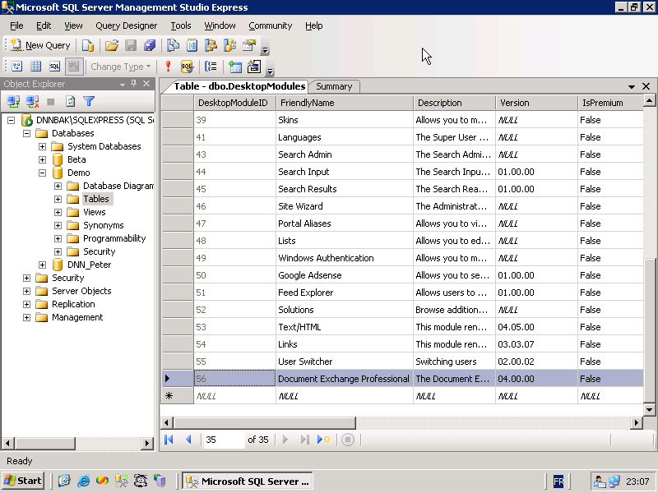
- Go to the web.config and verify the bold sections in the extract below
<modules>
…
<remove name="WebDAVModule" />
<add name="WebDAVAuthenticationModule" type="Bring2mind.DNN.Modules.DMX.WebDAV.AuthenticationModule, Bring2mind.DNN.Modules.DMX.WebDAV" />
</modules>
<handlers>
…
<remove name="WebDAV" />
<add name="DMXDAV Hanlder" path="dmxdav.axd" verb="GET,HEAD,PUT,OPTIONS,PROPFIND,PROPPATCH,COPY,MOVE,DELETE,MKCOL,LOCK,UNLOCK,DEBUG" type="Bring2mind.DNN.Modules.DMX.WebDAV.DavHandler, Bring2mind.DNN.Modules.DMX.WebDAV" validate="false" />
<add name=" DMXDAV Wildcard Handler" path="/" verb="OPTIONS,PROPFIND" type="Bring2mind.DNN.Modules.DMX.WebDAV.DavHandler, Bring2mind.DNN.Modules.DMX.WebDAV" validate="false" />
</handlers>

If any of the above are missing or incorrect you can use the new web.config administration screen in DMX to tune this.
- Verify the changes in IIS outline in the previous section.

If all of the above checks out the module is correctly installed.

Debugging WebDAV
Probably one of the technically most challenging aspects of the module is getting the WebDAV server to work correctly. The reason for this is that this part relies on the correct “routing” of WebDAV traffic to the WebDAV component. Routing means: making sure that url xyz goes to the right bit of logic on the server. IIS is responsible for this and among other things it reads the web.config to see what modules to call and which handler to call. This is why the handlers and modules sections in the web.config are so important. A couple of blog posts explain this in greater detail:
http://www.bring2mind.net/Company/News/tabid/155/EntryId/94/Handlers.aspx
http://www.bring2mind.net/Company/News/tabid/155/EntryId/95/-Http-Modules.aspx
To properly debug this you need a tool to look at what is happening between your client PC and the server. Luckily such tool exists for free. It’s called Fiddler. You can get it here: http://www.fiddler2.com/fiddler2/
A blog post outlining how to use Fiddler to examine and analyze webdav traffic is here:
http://www.bring2mind.net/Company/News/tabid/155/EntryId/64/How-to-debug-your-DMX-WebDAV-using-Fiddler.aspx
And more information in this article:
http://www.bring2mind.net/Company/News/tabid/155/EntryId/100/Notes-About-WebDAV.aspx

Permissions
A frequent cause of problems is erroneous permissions on files on the hard drive of the server. This can lead to very unexpected and disastrous situations. This commonly happens when someone moves files from one place into the website. Or restoring from a backup. In short: if the asp.net worker process cannot do with the files what it expects/should be able to do, you can be in for a surprise. There is a blog post here about this phenomenon:
http://www.bring2mind.net/Company/News/tabid/155/EntryId/99/Permissions-permissions-permissions.aspx

Host Settings
Note that if you have issues with Document Exchange rendering or downloading (and with any other module for that matter) it’s a good idea to switch off all html downstream processing such as compression and white space filtering. For DMX to work Whitespace filtering must be switched off.
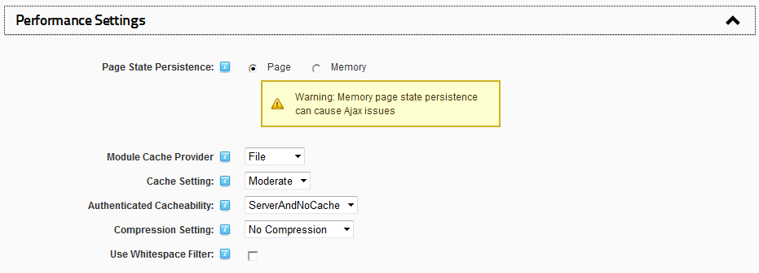

Note that whitefiltering does not improve performance if compression is also used. Unfortunately the whitespace filter rule built into DNN concatenates some Javascript lines that are built into a third party component used in DMX with the effect that the DMX interface no longer works and remains blank.
Compression can be turned on but exclude the download path if you have any issues with broken files being sent over:
desktopmodules/bring2mind/dmx/download.aspx
It is hard to predict how compression and other downstream processing will evolve so at this point it’s impossible to say exactly how you should tune your DNN installation for maximum performance. You just need to be aware that sometimes it mangles things it shouldn’t. As a general advice therefore: play around with it and keep it in the back of your head when debugging DNN installations.

Upgrading DMX 3
If you’re upgrading DMX 3 then you just need to perform one more operation besides the regular procedure for a fresh installation. After installation you won’t see the content in the DMX yet as neither the permissions nor the title of items have been updated.
- After the installation of the module and logged in as host you’ll need to go to one of the module instances.
- On the DMX menu you’ll find Admin > Run Scripts. Click this menu item.
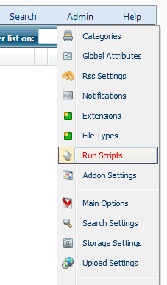
- You’ll see a dropdown with the various available scripts. You should be able to find one entitled DMX 3 to DMX 4 upgrade. Select this and click Run.
- You’ll also want to run the Reindex installation script to reindex all documents in the new search provider: Lucene.
You might encounter errors during the script. Keep a copy of the output of the screen just in case. It could help solve any issues later on.
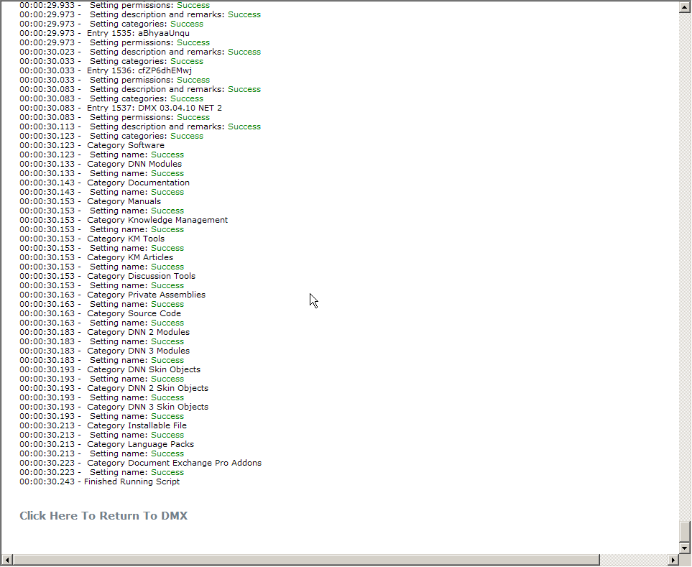

Uninstalling
In the event you wish to uninstall the module you MUST do the following:
- Log in as host in your DNN
- Go to ‘Extensions’ and click on the delete icon next to Document Exchange.
- Select ‘Delete Files’ and click Uninstall
- Manually delete the various DesktopModules/Portal/[PortalId]/DMX directories that have been used to save files (the DNN installer is unable to do this automatically)
In the event you cannot remove the installation using the DNN interface for whatever reason, here is how to remove DMX from your installation by hand:
- Log into your server and open the web.config
- Remove the entries in httpModules, modules, httpHandlers and handlers that contain the word Bring2mind (see the web.config extract above in Installation Checking)
- On the server’s hard disk delete the DesktopModules/Bring2mind/DMX directory and the Bring2mind dlls in the bin directory (you can verify which dlls were installed by opening the Install.zip of the module)
- Manually delete the various DesktopModules/Portal/[PortalId]/DMX directories that have been used to save files
- Open your SQL Management Studio
- Delete all procedures, functions, views and tables prefixed with DMX_. Note you might have to retry a few times with the tables to get them all deleted.
- Go to the Packages and DesktopModules tables in SQL and find the record where ‘FriendlyName’ is ‘Document Exchange’. Delete these records.
The last action should remove both the definition of the module and any instances in the site. You should have a clean installation again after this procedure.

Licensing and Activation
Document Exchange needs to be activated to work. This is not necessary if you address the module locally (i.e. through http://localhost/etc). The activation mechanism supports trial licenses (and hence activation). You can activate the module for 30 days without purchase. Note that the module does not become fully crippled when not activated. Instead all upload/edit actions will be disallowed. Download of existing content is still possible. This change assures that you now have time to contact us if something goes wrong with your installation and the module refuses to activate for whatever reason. During this period users can at least still access content.
Note that a license is something different than an activation. In the most common scenario you buy a license to use DMX on a single DNN installation. In most cases, customers will also want to use the software in a staging environment as well as their production environment. Keeping a running mirror copy of your production site for testing is good practice, and we do not require you to purchase extra licenses for this. So we sell you the right to use the software on one production DNN installation but we allow you to use it on your staging site as well. Because DMX needs to be activated to work, this means you’ll need to activate twice. So you have one license and two activations. Note that if for some reason you need an extra activation you can always contact us.
During activation your DMX will get an activation key from the Bring2mind server. This server will identify the installation using a generated ‘server key’. This key contains information about the DNN installation as well as your license details. These details consist of an email address and an invoice code. When you purchase DMX, these details should be emailed to you. If you’re trying out DMX then you don’t need these details right now.
To activate DMX you should follow these steps:
- Log in as host in your DNN installation
- Go to a place where DMX is instantiated in the portal or add it to a page now
- Under the module’s menu you should find a menu item ‘License’. Select this
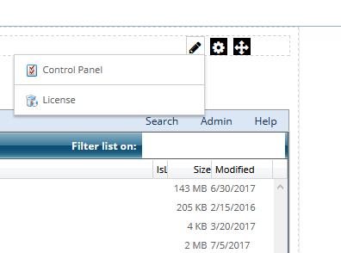
- You should now be directed to the activation screen. You’ll see the current state of your license.
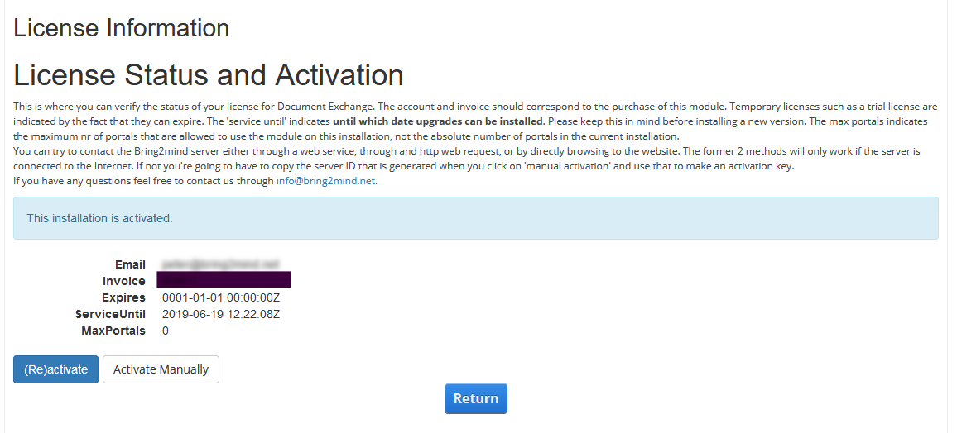
- Click on (re)activate and either fill in the account (email address) and invoice nr OR select ‘Trial license’ (the latter will disable the account/invoice text boxes).
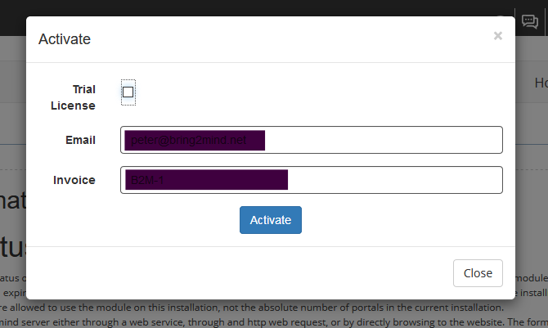
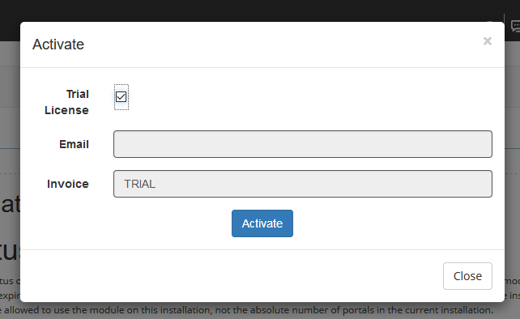
- You can now request activation. If successful the popup disappears and the data on the first screen should have been updated. Note: if the server has no access to the internet you should close the popup and click “manual activation” and follow the steps described there.
- If you’ve successfully activated you should see a screen with the license details and you can click ‘Update’. The following steps do not concern you.
- If you’ve not been able to activate automatically then click ‘Manual Activation’. This allows you to complete the activation process if your server is somehow unable to access the Bring2mind server over the internet. You’ll be taken to a web page where you can fill in the same details as before.
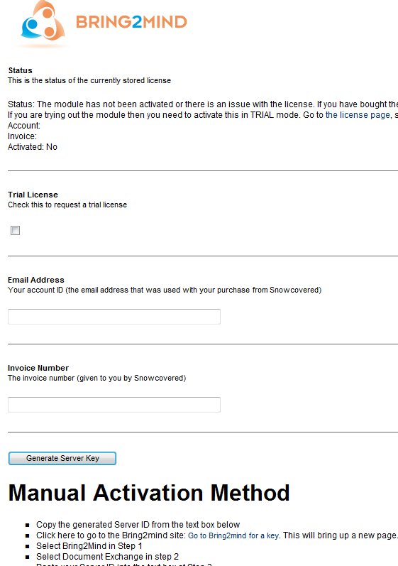
- There is a point by point explanation how to complete the activation process in this way. Central in this is a so-called server key which you need to enter on a specific page on the Bring2mind site and it will return an activation code for you which you need to paste back onto this page.
Note: when entering the activation key and clicking “submit” scroll down to the bottom of the page again to see what happened. It should state that the license has been saved.
- You should now have activated the module and you can click ‘Update’ to save the license and go back to your installation.
Note that the activation is bound to the DNN installation. You should be able to upgrade or move server without breaking this. If the module refuses to activate and you feel it should, please don’t hesitate to contact us.

Upgrading
You will receive a notification when a new release of DMX becomes available. This notification is generated by the place through which you bought the product and/or by the Bring2mind server.

License model, upgrades and “service period”
Since DMX 4 we changed the license to a subscription model. You buy the license once and renew it every year to receive upgrades for free. Because of the way in which the DNN Store works, we cannot link this to the notification so you will need to check yourself if you are entitled to the upgrade. On the license page of the module you will see the following field: Service Until.
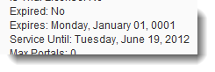
The service until date is the date until which you are entitled to upgrades and support. When a new update to the module is released or if you are reinstalling and you wish to use the latest version, you will need to check this date exceeds the date of the release of the version of DMX you’re installing. There are 2 places where you can check this.

Installation release date warning
During installation you will see the release date of the module highlighted in the Release Notes:
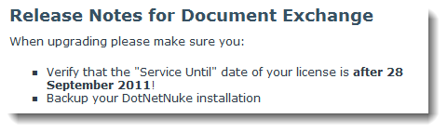

Release list on Bring2mind Site
If you go to the downloads page on the Bring2mind site and follow the link to the Document Exchange module (http://www.bring2mind.net/Downloads?EntryId=2793) you will see the previous versions and their dates:
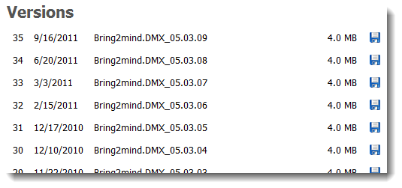

Installing the update
As with most other modules on DNN all you need to do is to install the new zip as if you were installing it for the first time. DNN analyses the zip file and takes care of correct upgrading. We do recommend you backup your installation. Reasons for this are, among others, that (a) you cannot roll back a module installation, and (b) a module installation that fails halfway through is very hard to repair. We test as best as we can but we cannot guarantee the module plays nice with other modules. Module clashes are rare but have been known to happen. It is therefore a good idea to test any upgrade first and roll back if there are (serious) issues and contact us.
Installation failures can happen for a host of reasons. We mentioned before the executionTimeout and the maxRequestLength settings in the web.config which may influence a successful install of a module. Another frequent reason for a failed upgrade is related to disk permissions. When DNN does the upgrading it will overwrite a number of files on the system. As it runs under asp.net it is subject to restricted permissions (it can’t for instance write to C:\Windows). If you’ve moved or unzipped a DNN installation to the server you might have forgotten to propagate the correct permissions to all files of the DNN installation and DNN won’t, for instance, be able to overwrite the dlls in the bin folder. This inevitably leads to a broken installation. And it is more common than most think. The common scenario is when a DNN installation is moved from one server to another. Or if it comes out of a backup. You must set disk permissions correctly for DNN to function correctly.

WebDAV
WebDAV (Web Distributed Authoring and Versioning) is a very exciting technology that has been around since the 1990’s to allow users to edit and save documents over HTTP. Even though this technology is dated, numerous software products can act as clients for WebDAV, notably the Microsoft Office suite. So a user could open up a Word document from within Word without first downloading from the website and manually having to upload afterwards. This technology does require a few tweaks to how you operate your DNN installation, however.

Paths
WebDAV uses specific paths to access documents in DMX. These contain the “magic” keyword “dmxdav.axd”. Paths will look like this: https://www.myserver.com/dmxdav.axd/myfolder/myfile.docx. When loading a WebDAV resource, however, most clients assume that the entire path is part of the same WebDAV installation. As a consequence you cannot use this technology if your DNN installation is in a virtual path or with child portals. I.e. when your home page is at http://www.myserver.com/mydnnsite. This will throw off WebDAV and you will get errors connecting.

Security
WebDAV passes outside of DNN’s own security. DMX includes its own component to deal with this. This component runs on every web request to WebDAV. It checks first if the user has already been authenticated on the request. This could be the case when using LDAP for DNN authentication for instance. If the user has not been authenticated he/she will be challenged using either Digest authentication or Basic authentication. It is important that you have some understanding of these technologies so you can assess the implications.

Digest Authentication
This authentication mechanism uses MD5 hashes to send a hash of the user’s password and request to the server which creates the same hash locally and compares these. This authentication mechanism became popular as it meant passwords didn’t need to be sent over the line any more during authentication. However, it requires that the password is available on the server. Later this has become a big nono in the security community. Storing your users’ passwords in the database means you open up the possibility that after a hack those passwords would be downloaded and used on other sites with those users’ details. This is why nowadays DNN does not store passwords, but instead just a hash of it. This is specified in the web.config if you want to verify or change this.
As a result WebDAV will no longer work using digest authentication on modern DNN Platform installations unless you reset the passwords and tell DNN to store them “encrypted” instead of “hashed”. But we advise against this.

Basic Authentication
WebDAV software will also accept basic authentication. In this mechanism the user’s username and password are sent in base 64 encoded format. This is effectively in clear text. Basic authentication is therefore highly insecure if used over a plain http connection. Instead you should use SSL to make sure the entire request is encrypted. This is why most client software will be fine to use basic authentication as long as the connection is secure (https). DMX WebDAV follows suit and allows basic authentication if and only if the connection is secure.
What this means is that you will need to make sure your DNN installation is run over SSL. Keep in mind that DMX shows WebDAV links according to how the user is connected. So http if the page is http, https if over SSL. And keep in mind this is cached, so you’ll need to enforce the DMX page is always run https if you wish to have accurate WebDAV links.

Enabling
By default, DMX’s WebDAV is not accessible. It is governed by the settings on the Main Options page. There are two parts that determine if someone sees the WebDAV links in the UI and if he/she can access WebDAV. There are the application permissions:
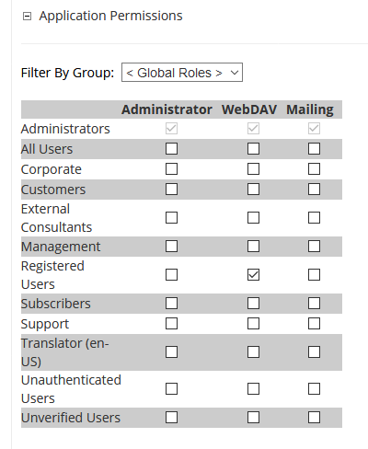
This allows you to tweak access per role in DNN. Then there is also a “master switch” just underneath with the WebDAV settings:
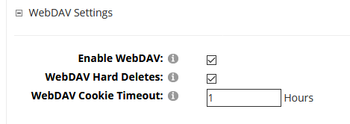
Normally if both these are set correctly a user should see the WebDAV links in the UI.

Css and Bootstrap
The module leverages 3 css components: ComponentArt, DNN and Bootstrap.

ComponentArt
The ComponentArt css is only used in the two main Ajax views (AjaxTwoPanel and AjaxThreePanel). Unfortunately, due to the design of this (third party) component we’ve not been able to properly isolate this css, so it is not impossible that your theme/skin’s css influences this css. If DMX looks like it has css issues, try to switch to the default Xcillion skin first to see if the problem is related to skin css clashing with this css. If that is the case there are no simple paths out. We cannot provide support for each and every skin that is out there so all we can do to help is say “use the browser dev tools and analyse where css is being overridden by your skin’s css”. Again, this only applies to the “Windows Explorer”-like UI that is DMX’s default.

DNN Css
In several places DMX uses DNN’s standard css classes to organize layout. You can see this in the edit screen for instance. Although somewhat dated, this should work regardless of your specific environment. If something is wrong on these screens then probably you’re experiencing issues elsewhere as well.

Bootstrap
We find that it is easiest to use Bootstrap to provide users with a modern looking experience in DMX. So we’re using it in more and more places in the module. Because we ship with our own Bootstrap library it is not impossible it clashes with your skin’s Bootstrap if it uses that, too. To help avoid clashes we’ve added a switch in the main options to not serve Bootstrap from our directory. If you switch this off we assume that your skin will serve Bootstrap (both css and javascript).

