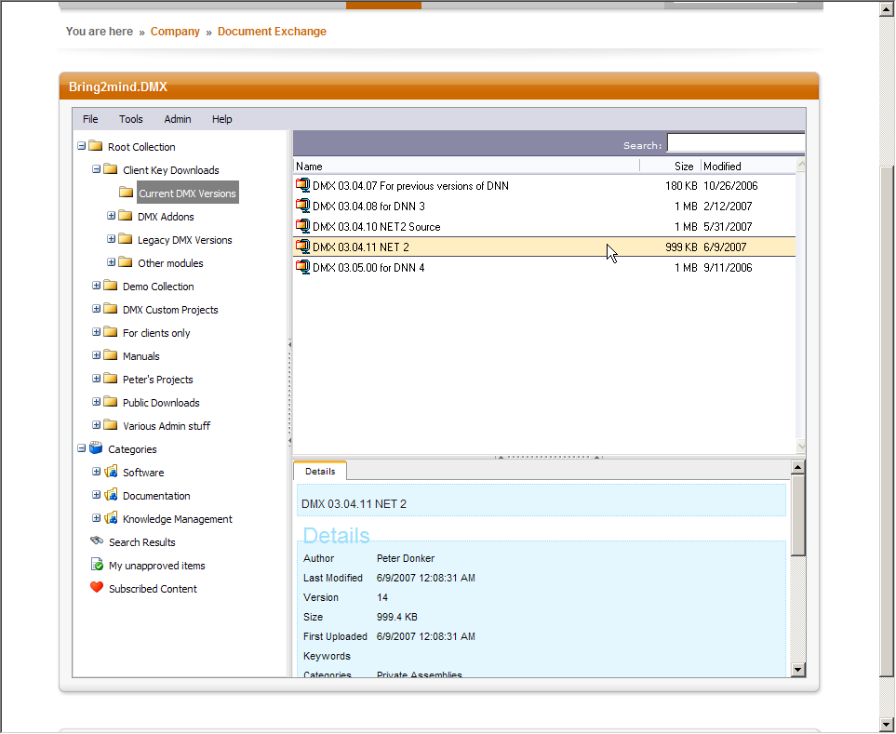
Document Exchange Professional 4 Installation

Conventions
DotNetNuke is a CMS (Content Management System) built on Microsoft’s .Net framework. DotNetNuke is abbreviated to DNN. It is also referred to as the ‘framework’ or the ‘platform’ at times.
Document Exchange is a module for DNN. A module is an extension of the DNN framework and comes in the form of a zip file. The zip file includes a manifest (a file with the extension .dnn) that tells DNN how to install it. Document Exchange (Professional) is abbreviated to DMX.
If you are new to DotNetNuke and installing modules, I strongly urge you to buy ‘DotNetNuke for Dummies’ (L. Young et al. 2007. Wiley). An excellent book that will get you started on this CMS.

Prerequisites
- IIS 6
For WebDAV to function correctly you’ll need to be running on IIS 6 or above. You’ll also need access to the management panel of IIS.
- SQL 2005
DMX uses some features of SQL Server 2005. It will not work on SQL Server 2000.
- DotNetNuke 04.05.03 or higher
DMX 4 was compiled on a DNN 04.05.03 so this is the minimum version of the platform on which it will run. There are three other components on which it depends which are shipped with it in the distribution: RadUpload, Lucene, and ComponentArt. Under normal circumstances you should never have to be concerned by these dependencies.
If for some reason you get ‘dependency errors’ in your installation (this is very rare), check the version nr of these dlls (located in the bin directory of your DNN installation) and verify that they are equal to or bigger than the version nrs of the dlls in the distribution zip.

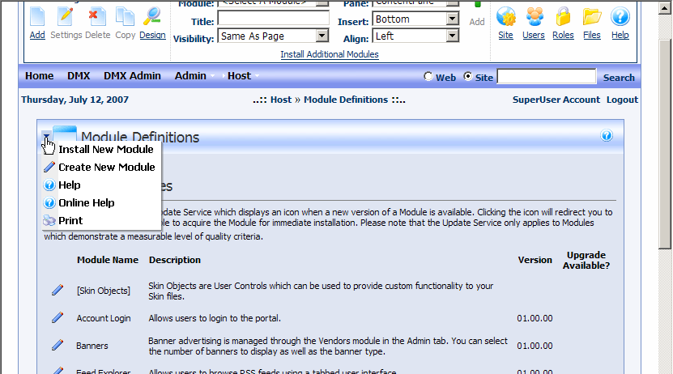
Installation
The installation of the module is similar to that of any module that is made for DNN. There are a number of things to keep in mind though, as well as an adjustment to IIS that is required to enable WebDAV. Whether you’re installing DMX for the first time into your installation or you’re upgrading an older version, the procedure is the same:
- Make a backup of your DNN installation and database. This is especially important if you’re upgrading a DMX 3 installation.
- Verify your web.config (see note below) for potential timeout issue
- Log in as host on your DNN installation
- Go to ‘Module Definitions’ under the host menu
- Select ‘Install New Module’ from the module list’s menu
- Browse to and select the Bring2mind.DMX.04.xx.xx.zip and click upload
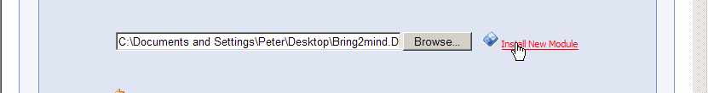
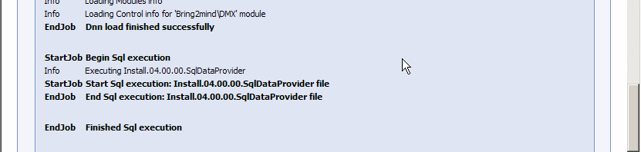
- Wait for all processing to finish. Note that during this time the following is happening:
- The zip file (around 1.5 Mb) is uploaded to the installation
- The contents are checked, the manifest file is extracted and examined
- Necessary SQL scripts are run
- Files are copied into place
- The module is registered in the installation
The above can easily take a couple of minutes. Take this into account.
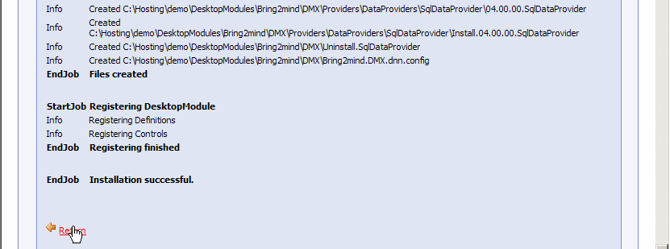
- The web page you’re looking at should show you an installation report. Scroll down this report to check if there are any red text blocks signifying there were errors during install. If there were continue reading the ‘Installation Checking and Errors’ section below.
When no errors have shown up you have installed the module into the DNN installation. You’ll need to be aware of the following:
During the installation/upgrade the module will make some changes to the web.config. When uninstalling the module these changes have to be undone or your whole DNN installation will refuse to work. Check the uninstall procedure for this.

IMPORTANT: web.config and timeouts
The DMX module is with 3Mb a sizeable installation. On slower connections and/or slower servers you may run into an IIS execution timeout. This is not easy to repair and can leave your DMX installation useless. Please verify the following:
In your web.config you’ll find the following line:
<httpRuntime useFullyQualifiedRedirectUrl="true" maxRequestLength="8192" requestLengthDiskThreshold="8192" />
This line tells IIS that the maximum upload size (maxRequestLength) is 8 Mb. This is fine for our purposes. HOWEVER, what it doesn’t mention is another parameter: executionTimeout. This parameter tells IIS after how much time it should kill the ongoing request process. This is to prevent against Denial Of Service (or DOS) attacks for instance. By default this is set to 90 seconds. This is easily reached installing DMX 4. Note this is not just the time for upload but also the time for running any scripts and registering the module.
You will probably want to set this parameter to a higher value. So you can change the line to read:
<httpRuntime useFullyQualifiedRedirectUrl="true" maxRequestLength="8192" requestLengthDiskThreshold="8192" executionTimeout="240" />
Now the timeout is set to 4 minutes. If you feel you’re on a low bandwidth connection to your server set it even higher. You might also want to examine the maxRequestLength because it also caps the max file size to upload into DMX.

Changes to IIS
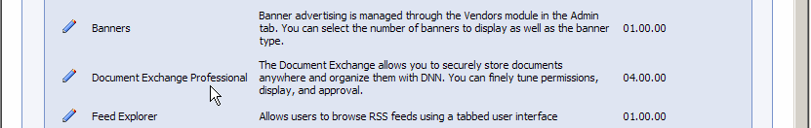
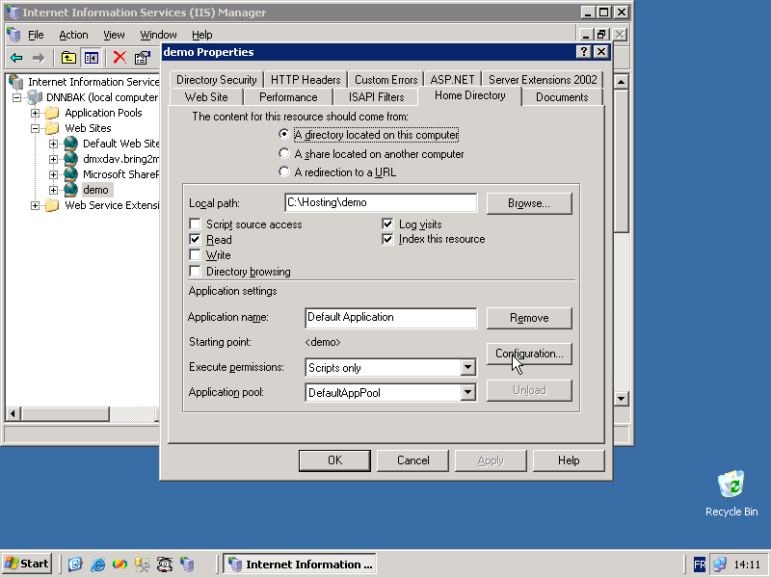
The WebDAV support relies on the changes made in the web.config and also a change to IIS. The component uses virtual paths to communicate with clients about content. It is important that IIS is informed about this and does not step in to prevent processing. To complete this you should (explanation for IIS6):
- Log in as administrator on your server
- Go to the IIS control panel and call up the properties of the web site of the installation
- Go to the ‘Home Directory’ tab
- Double click on the ‘.axd’ extension mapping in the ‘Application Extensions’ list
- Change the Verbs list in the ‘Limit to:’ text box to read:
GET,HEAD,PUT,OPTIONS,PROPFIND,PROPPATCH,COPY,MOVE,DELETE,MKCOL,LOCK,UNLOCK,DEBUG
- Copy the text under ‘Executable’ to the clipboard (in .net 2 it should be c:\windows\microsoft.net\framework\v2.0.50727\aspnet_isapi.dll)
- Under ‘Wildcard application maps’ click ‘Insert…’
- In the dialog fill in the clipboard text under Executable and uncheck ‘Verfiy that file exists’. Click OK.
- Make sure you leave the rest untouched (check illustration for final result)
- Click OK three times to exit the Application Configuration and website properties
- Go to the ‘Web Service Extensions’ node of your IIS panel
- Make sure WebDAV is ‘Prohibited’. DMX integrates its own WebDAV, the Windows WebDAV conflicts with this.
Now you should be set to use WebDAV in your DNN/DMX installation.
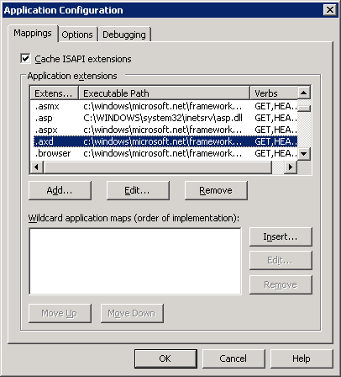
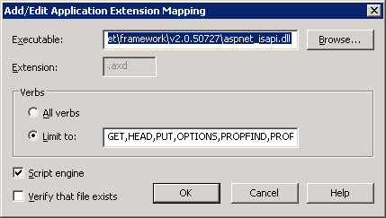
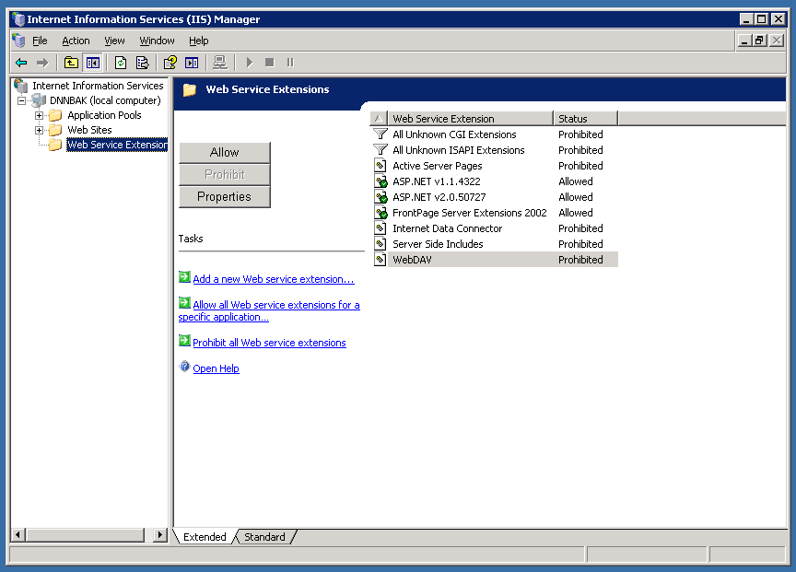
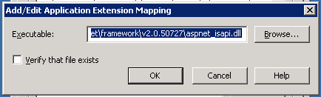
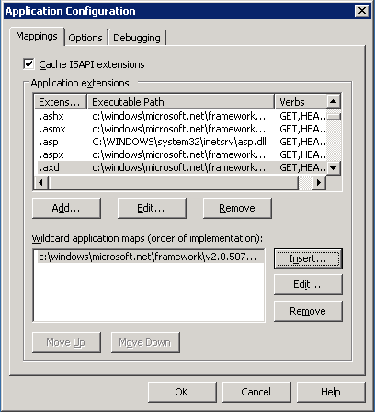

Installation checking and errors
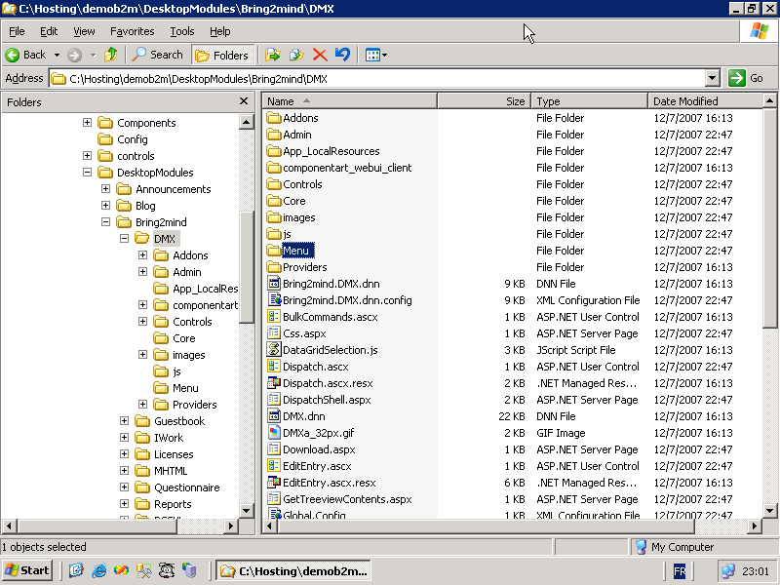
There are a number of things you can do to determine to what degree the installation has succeeded.
- On the server use the Explorer to go the directory where DNN is installed and check that underneath that you find DesktopModules\Bring2mind\DMX. This is the installation directory of various controls that this module uses. If this is absent then the installation is critically flawed. Verify that the ASP.NET worker process (by default ‘NETWORK SERVICE’ under IIS6) has sufficient rights to create directories and files in this location.
- In the DesktopModules\Bring2mind\DMX folder there should be sub folders called ‘Menu’ and ‘Core’. If not then it looks like a failed upgrade of DMX 3 to 4. Again check the file permissions as mentioned above.
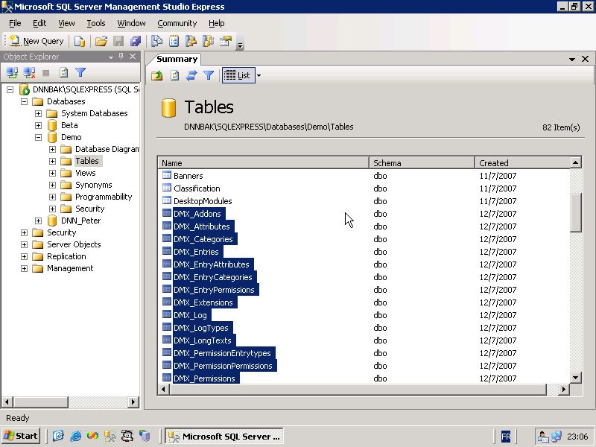
- Open your SQL Server Management Studio and open the database that your DNN installation uses (exact procedure might vary according to your Windows/SQL/DNN setup). Verify that there are a bunch of tables and stored procedures that begin with DMX_ (prefix with any object qualifier you’ve defined in your web.config). If there are none, then the whole data layer is missing. If you do not find the table DMX_Permissions but you do find DMX_Entries then it looks like a failed upgrade of DMX 3 to 4. In any case the error is critical. Check that in our web.config you’ve set the SQL connection string correctly in both connectionStrings and under appSettings. Also verify the SqlDataProvider section in the web.config.
- Open the DesktopModules table and verify there is a record where the ‘FriendlyName’ is ‘Document Exchange Professional’. In ModuleDefinitions check there is a record where ‘FriendlyName’ is ‘Bring2mind\DMX’. Make a mental note of the ModuleDefId. Check the ModuleControls table to see there are a bunch of records that have this ModuleDefId. If any of this doesn’t check out the module is not registered and will not appear in your DNN installation.
- Go to the web.config and verify the bold sections in the extract below
<httpModules>
<add name="Compression" …
… PublicKeyToken=31bf3856ad364e35" />
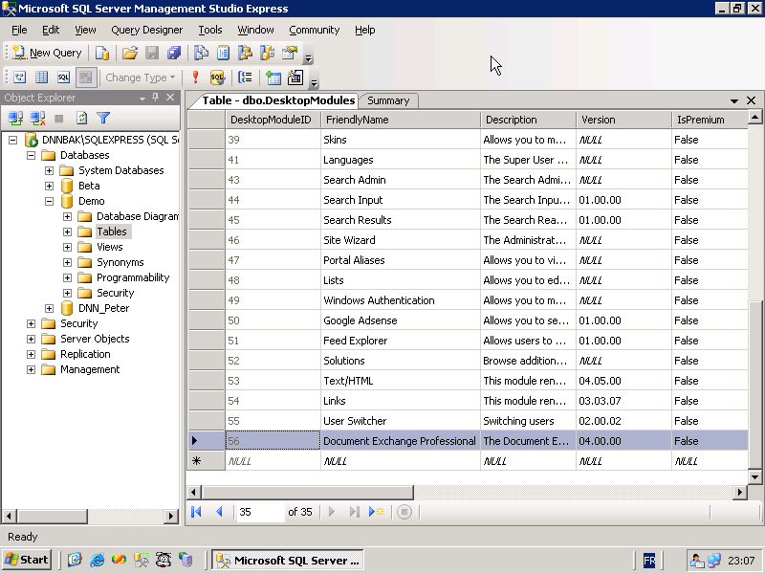
<add name="RadUploadModule" type="Bring2mind.Telerik.WebControls.RadUploadHttpModule, Bring2mind.Telerik.RadUpload.Net2" />
<add name="WebDAVAuthenticationModule" type="Bring2mind.DNN.Modules.DMX.WebDAV.AuthenticationModule, Bring2mind.DNN.Modules.DMX.WebDAV" />
</httpModules>
<httpHandlers>
<remove path="*.asmx" …
… validate="false" />
<add path="Bring2mind.Telerik.RadUploadProgressHandler.aspx" verb="*" type="Bring2mind.Telerik.WebControls.RadUploadProgressHandler, Bring2mind.Telerik.RadUpload.Net2" />
<add path="/" verb="OPTIONS,PROPFIND" type="Bring2mind.DNN.Modules.DMX.WebDAV.DavHandler, Bring2mind.DNN.Modules.DMX.WebDAV" validate="false" />
<add path="dmxdav.axd/*" verb="GET,HEAD,PUT,OPTIONS,PROPFIND,PROPPATCH,COPY,MOVE,DELETE,MKCOL,LOCK,UNLOCK,DEBUG" type="Bring2mind.DNN.Modules.DMX.WebDAV.DavHandler, Bring2mind.DNN.Modules.DMX.WebDAV" validate="false" />
</httpHandlers>
- Verify the changes in IIS outline in the previous section.

If all of the above checks out the module is correctly installed.

Host Settings
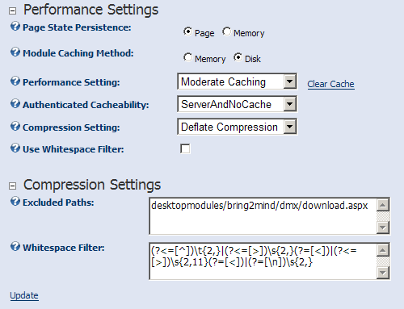
Note that if you have issues with Document Exchange rendering or downloading (and with any other module for that matter) it’s a good idea to switch off all html downstream processing such as compression and white space filtering. For DMX to work Whitespace filtering must be switched off. Compression can be turned on but you must exclude the download path:
desktopmodules/bring2mind/dmx/download.aspx
It is hard to predict how compression and other downstream processing will evolve so at this point it’s impossible to say exactly how you should tune your DNN installation for maximum performance. You just need to be aware that sometimes it mangles things it shouldn’t. As a general advice therefore: play around with it and keep it in the back of your head when debugging DNN installations.

Upgrading DMX 3
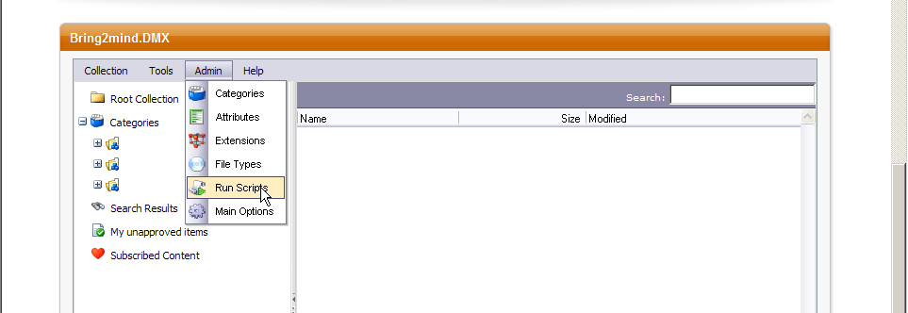
If you’re upgrading DMX 3 then you just need to perform one more operation besides the regular procedure for a fresh installation. After installation you won’t see the content in the DMX yet as neither the permissions nor the title of items have been updated.
- After the installation of the module and logged in as host you’ll need to go to one of the module instances.
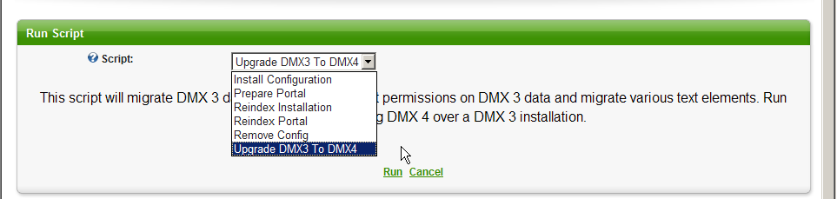
- On the DMX menu you’ll find Admin > Run Scripts. Click this menu item.
- You’ll see a dropdown with the various available scripts. You should be able to find one entitled DMX 3 to DMX 4 upgrade. Select this and click Run.
- You’ll also want to run the Reindex installation script to reindex all documents in the new search provider: Lucene.
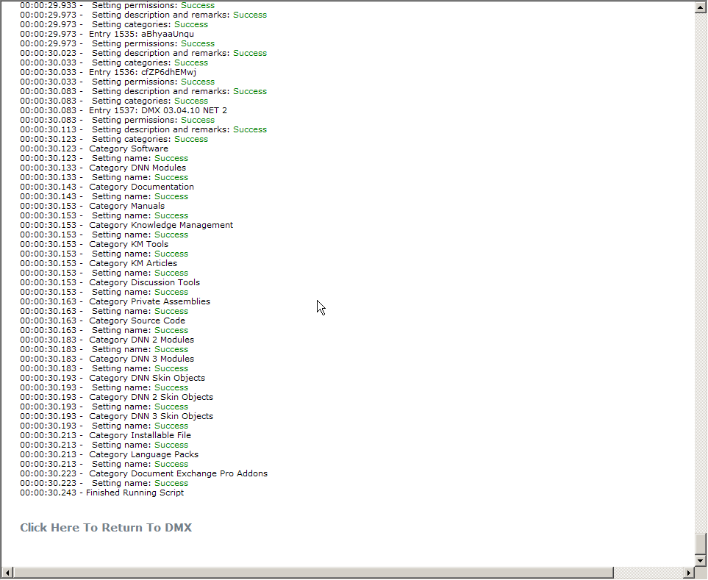
You might encounter errors during the script. Keep a copy of the output of the screen just in case. It could help solve any issues later on.

Uninstall
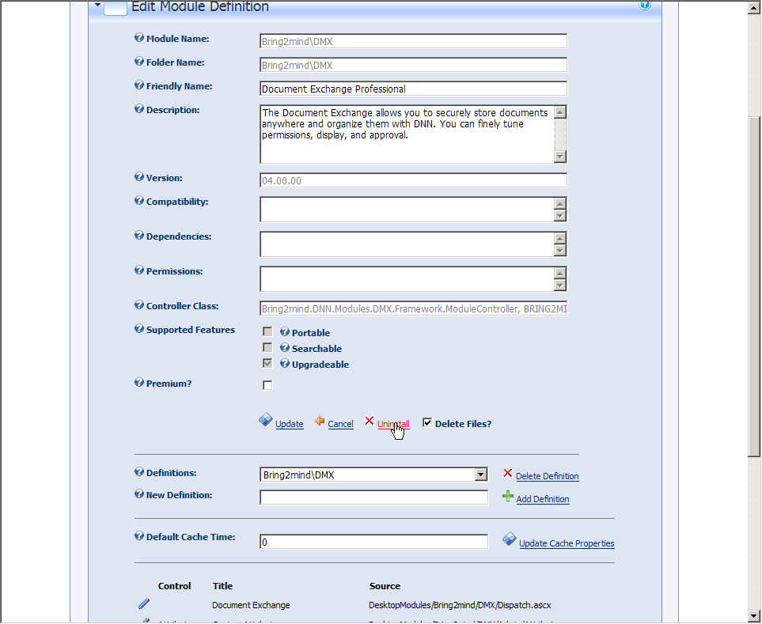
In the event you wish to uninstall the module you MUST do the following:
- Log into your server and open the web.config
- Remove the TWO added entries to httpModules (see the web.config extract above in Installation Checking).
- Remove the THREE added entries to httpHandlers
- Log in as host in your DNN
- Go to ‘Module Definitions’ and click on the pencil icon next to Document Exchange Professional.
- Select ‘Delete Files’ and click Uninstall
- Manually delete the various DesktopModules/Portal/[PortalId]/DMX directories that have been used to save files
In the event you cannot remove the installation using the DNN interface for whatever reason, here is how to remove DMX from your installation by hand:
- Log into your server and open the web.config
- Remove the TWO added entries to httpModules (see the web.config extract above in Installation Checking).
- Remove the THREE added entries to httpHandlers
- Delete the DesktopModules/Bring2mind/DMX directory
- Manually delete the various DesktopModules/Portal/[PortalId]/DMX directories that have been used to save files
- Open your SQL Management Studio
- Delete all procedures and tables prefixed with DMX_. Note you might have to retry a few times with the tables to get them all deleted.
- Go to DesktopModules and find the record where ‘FriendlyName’ is ‘Document Exchange Professional’. Delete this record.
The last action should remove both the definition of the module and any instances in the site. You should have a clean installation again after this procedure.

Licensing and Activation
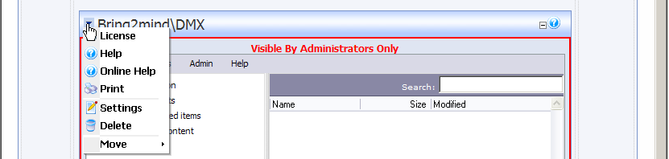
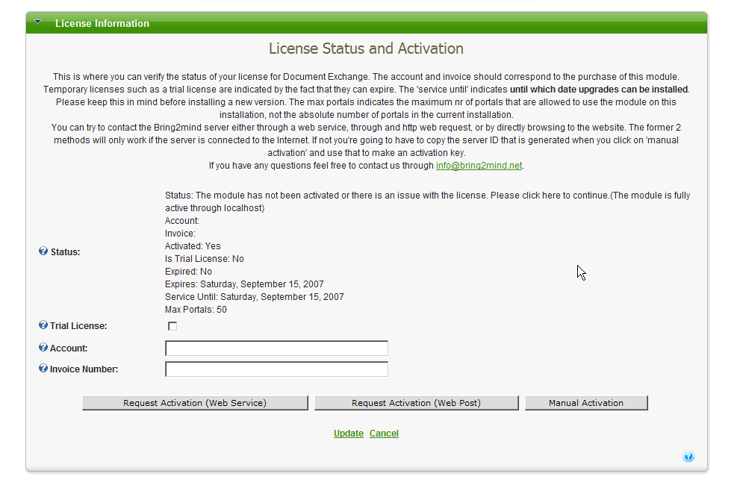
Like DMX 3, DMX 4 needs to be activated to work. And just like under DMX 3 this is not necessary if you address the module locally (i.e. through http://localhost/etc). Unlike DMX 3, DMX 4 does not become fully crippled when not activated. Instead all upload/edit actions will be disallowed. Download of existing content is still possible. This change assures that you now have time to contact us if something goes wrong with your installation and the module refuses to activate for whatever reason. During this period users can at least still access content.

Another change from DMX 3 to DMX 4 licensing is that DMX 4 now supports trial licenses (and hence activation). You can activate the module for 30 days without purchase.
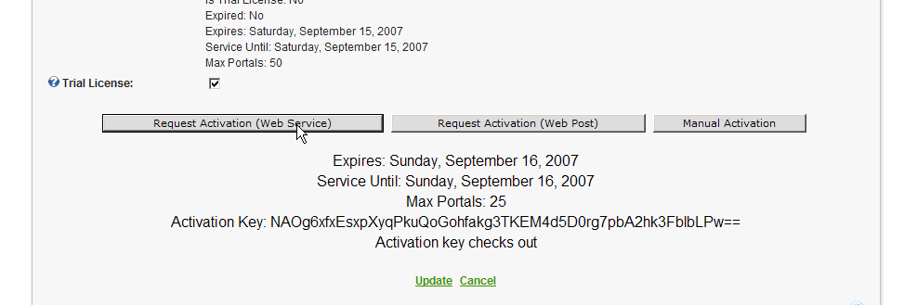
Note that a license is something different than an activation. In the most common scenario you buy a license to use DMX on a single DNN installation. In most cases, customers will also want to use the software in a staging environment as well as their production environment. Keeping a running mirror copy of your production site for testing is good practice, and we do not require you to purchase extra licenses for this. So we sell you the right to use the software on one production DNN installation but we allow you to use it on your staging site as well. Because DMX needs to be activated to work, this means you’ll need to activate twice. So you have one license and two activations. Note that if for some reason you need an extra activation you can always contact us and explain the situation. We normally grant always be able to have a working DMX on their production site.
During activation your DMX will get an activation key from the Bring2mind server. This server will identify the installation using a generated ‘server key’. This key contains information about the DNN installation as well as your license details. These details consist of an email address and an invoice code. When you purchase DMX, these details should be emailed to you. If you’re trying out DMX then you don’t need these details right now.
To activate DMX you should follow these steps:
- Log in as host in your DNN installation
- Go to a place where DMX is instantiated in the portal or add it to a page now
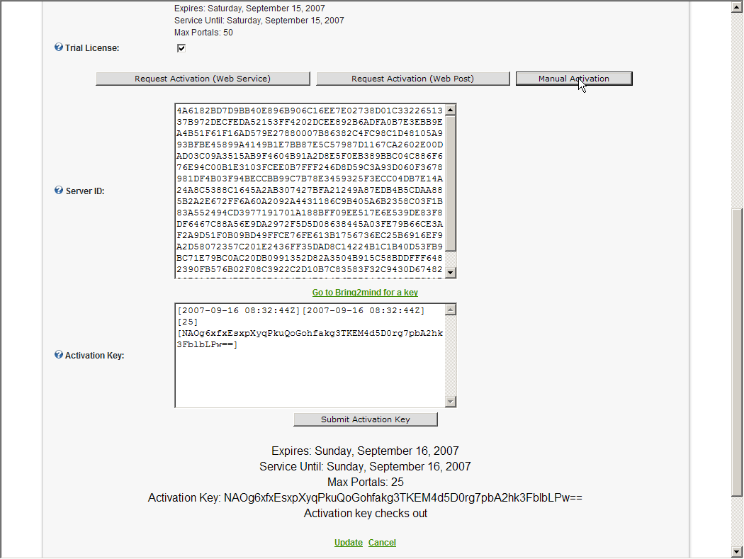
- Under the module’s menu you should find a menu item ‘License’. Select this
- You should now be directed to the activation screen. You’ll see the current state of your license.
- Either fill in the account (email address) and invoice nr OR select ‘Trial license’ (the latter will disable the account/invoice text boxes).
- You can request activation through a web service or by web request. Try the first and if it fails, try the second. If any one is successful you should see a notification in your screen to that effect. If not there is nothing to worry about as we can also activate manually. Click ‘Request Activation’
- If you’ve successfully activated you should see a screen with the license details and you can click ‘Update’. The following steps do not concern you.
- If you’ve not been able to activate automatically then click ‘Manual Activation’. You’ll see two text boxes appear. One with a Server ID and one with the Activation Key (the current active one). You’ll also see a hyperlink to www.bring2mind.net. Please use this hyperlink to go to Bring2mind.net. You can also copy this hyperlink and use another (internet accessing) PC to go to this page.
- You’ll see a web page where you need to select the module and enter the ‘server key’ that you can copy from the activation screen. Use this page to generate a valid activation key.
- Copy the key from the bring2mind.net page to your DMX license screen in the Activation Key box and click ‘Submit activation key’. A message will appear at the bottom of the screen to confirm the activation.
- You should now have activated the module and you can click ‘Update’ to save the license and go back to your installation.
Note that the activation is bound to the DNN installation. You should be able to upgrade or move server without breaking this. If the module refuses to activate and you feel it should, please don’t hesitate to contact us.

