Document Exchange Installation
Version 5. December 2009
DotNetNuke is a CMS (Content Management System) built on Microsoft’s .Net framework. DotNetNuke is abbreviated to DNN. It is also referred to as the ‘framework’ or the ‘platform’ at times.
Document Exchange is a module for DNN. Document Exchange (Professional) is abbreviated to DMX. A module is an extension of the DNN framework and comes in the form of a zip file. The zip file includes a manifest (a file with the extension .dnn) that tells DNN how to install it.
If you are new to DotNetNuke and installing modules, I strongly urge you to buy ‘DotNetNuke for Dummies’ (L. Young et al. 2007. Wiley). An excellent book that will get you started on this CMS.
Contents
Document Exchange Installation 1
Prerequisites 2
Important: Upload Timeout 2
Installation 3
Important: Whitespace Filtering 4
Troubleshooting Installation 5
Upgrading from DMX 3 8
IIS tuning for WebDAV 9
Before we start: handlers and modules 9
IIS 6 9
IIS 7 12
Debugging WebDAV issues 14
License and Activation 15
Debugging Activation 17
Uninstalling 18
How to remove DMX from your installation by hand 18

Prerequisites
Before you start please check your installation complies with the following:
- IIS 6 or 7
For WebDAV to function correctly you’ll need to be running on IIS 6 or above. You’ll also need access to the management panel of IIS.
- SQL 2005
DMX uses some features of SQL Server 2005. It will not work on SQL Server 2000.
- DotNetNuke 04.06.02 or higher
DMX 5 was compiled on a DNN 04.06.02 so this is the minimum version of the platform on which it will run. There are three other components on which it depends which are shipped with it in the distribution: RadUpload, Lucene, and ComponentArt. Under normal circumstances you should never have to be concerned by these dependencies.
If for some reason you get ‘dependency errors’ in your installation (this is very rare), check the version nr of these dlls (located in the bin directory of your DNN installation) and verify that they are equal to or bigger than the version nrs of the dlls in the distribution zip.

Important: Upload Timeout
The DMX module is roughly 3 Mb. Depending on your connection speed it could easily take a couple of minutes to upload a file of this size. IIS protects a webserver against DOS (Denial Of Service) attacks by cutting off any long running web request. By default it does so after 90 seconds. As you can understand this means it can cut off while you’re installing DMX (in DNN 5 this problem has been alleviated by separating uploading from installing into separate web requests by doing an installation through a wizard interface). What happens if the process is terminated while installing? Well, that’s anyone’s guess because it can happen anywhere during the installation process. If it’s in the upload phase there is no issue. But if it is during the running of scripts or copying of files you might end up with a ‘half installed’ module. This is very hard to repair.
Typically a terminated process will result in you seeing an error screen and not DNN. Then you might try to go back one screen and try again. Now, if your installation was terminated somewhere during the running of scripts (i.e. parts of the database have already been installed) then you’ll probably see a slew of red error messages from those scripts that are trying to run a second time.
When you have a faulty installation and you’re seeing a lot of error messages upon second install, then you might have to manually uninstall the module. See the relevant chapter in this document.

Increasing the execution timeout
OK, after the above you realize it’s important we have enough time from IIS to actually upload and install the module. How much time you need depends on your bandwidth, but I find that setting it to anywhere between 5 and 10 minutes should be enough. You can increase the value by specifying it in the web.config. The default web.config has the following line in it:
<httpRuntime useFullyQualifiedRedirectUrl="true" maxRequestLength="8192" requestLengthDiskThreshold="8192" />
Now add the executionTimeout (note that XML is case sensitive) in seconds to this line thus:
<httpRuntime useFullyQualifiedRedirectUrl="true" maxRequestLength="8192" requestLengthDiskThreshold="8192" executionTimeout="300" />
So the above would set it to 5 minutes.

Installation
The installation of the module is similar to that of any module that is made for DNN. There are a number of things to keep in mind though, as well as an adjustment to IIS that is required to enable WebDAV.
Note: Whether you’re installing DMX for the first time into your installation or you’re upgrading an older version of DMX, the procedure is the same. You do not need to uninstall the module before upgrading. In fact: if you uninstall the module you remove all the data contained in it! So please just upload the module over the existing one as if you’re installing it from scratch. DNN knows which scripts it should run to properly upgrade your installation.
- Make a backup of your DNN installation and database. This is especially important if you’re upgrading a DMX 3 installation.
- Verify your web.config (see above) for potential timeout issue
- Log in as host on your DNN installation
- Go to ‘Module Definitions’ under the host menu
- Select ‘Install New Module’ from the module list’s menu
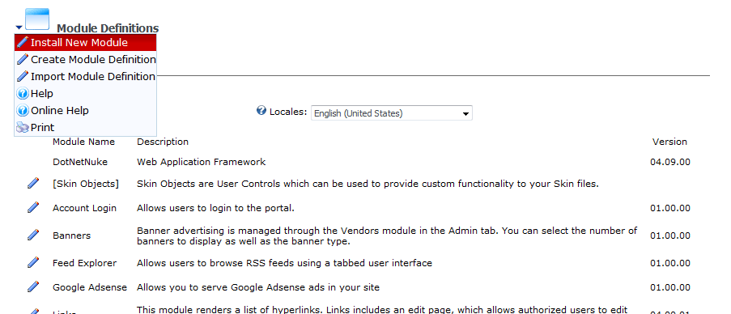
- Browse to and select the Bring2mind.DMX.05.xx.xx.zip and click upload
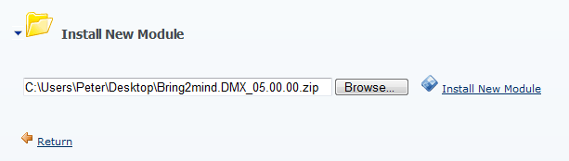
- Either (1) wait for all processing to finish in case of DNN 4 or (2) go through the install wizard to the end and click install. Note that during this time the following is happening:
- The zip file (around 1.5 Mb) is uploaded to the installation
- The contents are checked, the manifest file is extracted and examined
- Necessary SQL scripts are run
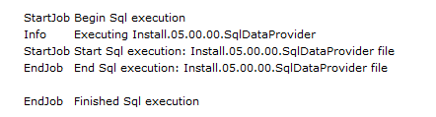
- Files are copied into place
- The module is registered in the installation
The above can easily take a couple of minutes. Take this into account.
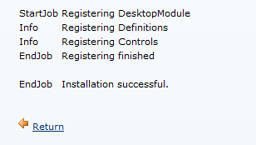
- The web page you’re looking at should show you an installation report. Scroll down this report to check if there are any red text blocks signifying there were errors during install. If there were continue reading the ‘Installation Checking and Errors’ section below.
Note: If you see error messages (normally in red) please copy them to include in communications with us!

When no errors have shown up you have installed the module into the DNN installation.
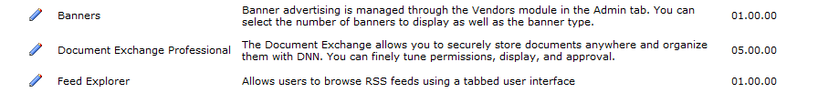
You’ll need to be aware of the following:
During the installation/upgrade the module will make some changes to the web.config. When uninstalling the module these changes have to be undone or your whole DNN installation will refuse to work. Check the uninstall procedure for this.

Important: Whitespace Filtering
If the Main UI of DMX refuses to properly render with various bits remaining white, i.e.
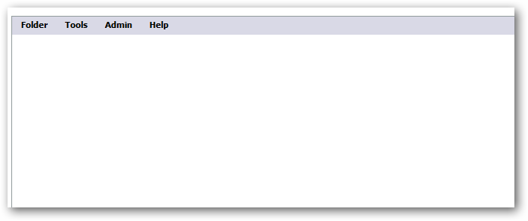
Then parts of the Javascript for the module are not correctly running. The most common cause for this is whitespace filtering. Check under Host Settings (Host menu on DNN) that this is switched off:
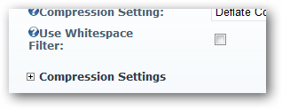
It doesn’t speed up your site to keep this one if you’re using compression (which we recommend). Note that if you’re using a third party DNN performance enhancement tool, you need to check that it doesn’t do whitespace filtering either.

Troubleshooting Installation
There are a number of things you can do to determine to what degree the installation has succeeded.
- On the server use the Explorer to go the directory where DNN is installed and check that underneath that you find DesktopModules\Bring2mind\DMX. This is the installation directory of various controls that this module uses. If this is absent then the installation is critically flawed. Verify that the ASP.NET worker process (by default ‘NETWORK SERVICE’ under IIS6) has sufficient rights to create directories and files in this location.
- In the DesktopModules\Bring2mind\DMX folder there should be a sub folder called ‘Resources’. If not then it looks like a failed upgrade of DMX 3 to 4/5. Again check the file permissions as mentioned above.
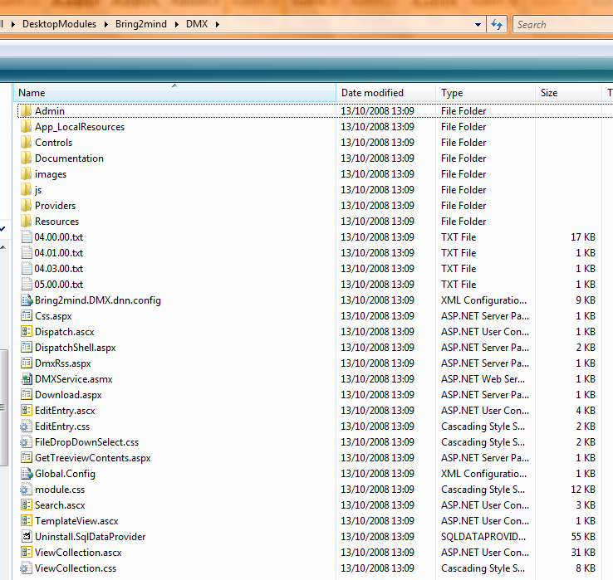
- Open your SQL Server Management Studio and open the database that your DNN installation uses (exact procedure might vary according to your Windows/SQL/DNN setup). Verify that there are a bunch of tables and stored procedures that begin with DMX_ (prefix with any object qualifier you’ve defined in your web.config). If there are none, then the whole data layer is missing. If you do not find the table DMX_Permissions but you do find DMX_Entries then it looks like a failed upgrade of DMX 3 to 4/5. In any case the error is critical. Check that in our web.config you’ve set the SQL connection string correctly in both connectionStrings and under appSettings. Also verify the SqlDataProvider section in the web.config.
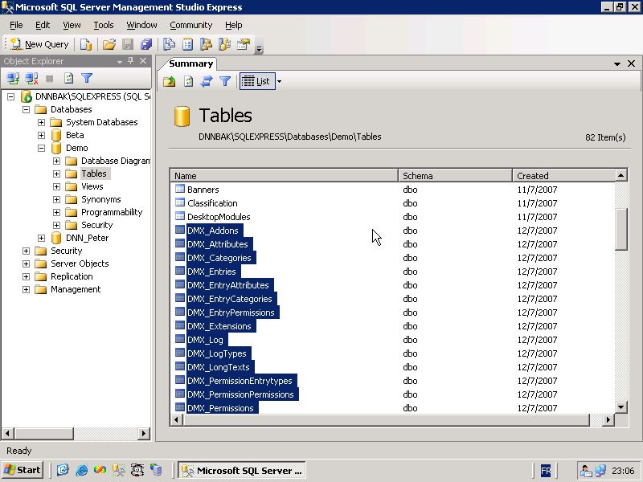
- Open the DesktopModules table and verify there is a record where the ‘FriendlyName’ is ‘Document Exchange Professional’. In ModuleDefinitions check there is a record where ‘FriendlyName’ is ‘Bring2mind\DMX’. Make a mental note of the ModuleDefId. Check the ModuleControls table to see there are a bunch of records that have this ModuleDefId. If any of this doesn’t check out the module is not registered and will not appear in your DNN installation.
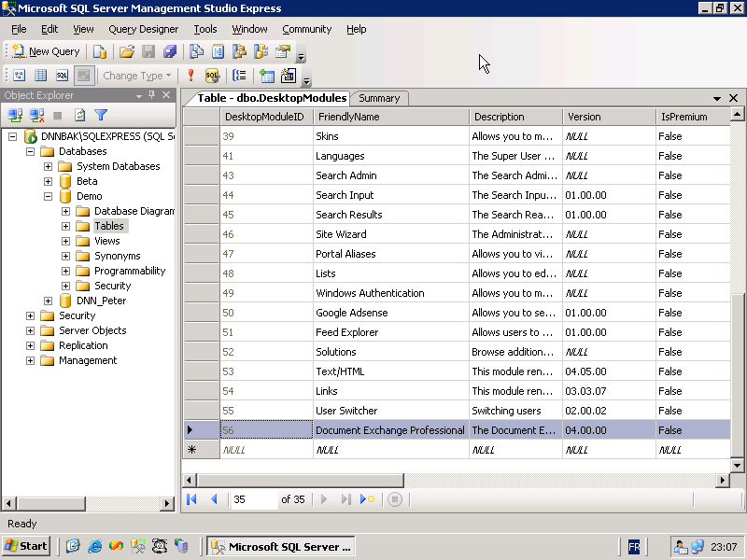
- Go to the web.config and verify the bold sections in the extract below
<httpModules>
…
<add name="RadUploadModule" type="Bring2mind.Telerik.WebControls.RadUploadHttpModule, Bring2mind.Telerik.RadUpload.Net2" />
<add name="WebDAVAuthenticationModule" type="Bring2mind.DNN.Modules.DMX.WebDAV.AuthenticationModule, Bring2mind.DNN.Modules.DMX.WebDAV" />
<add name="ComponentArtUploadModule" type="Bring2mind.ComponentArt.Web.UI.UploadModule, Bring2mind.ComponentArt.Web.UI" />
</httpModules>
<httpHandlers>
…
<add path="ComponentArtUploadProgress.axd" verb="*" type="Bring2mind.ComponentArt.Web.UI.UploadProgressHandler, Bring2mind.ComponentArt.Web.UI" />
<add path="Bring2mind.Telerik.RadUploadProgressHandler.aspx" verb="*" type="Bring2mind.Telerik.WebControls.RadUploadProgressHandler, Bring2mind.Telerik.RadUpload.Net2" />
<add path="dmxdav.axd" verb="GET,HEAD,PUT,OPTIONS,PROPFIND,PROPPATCH,COPY,MOVE,DELETE,MKCOL,LOCK,UNLOCK,DEBUG" type="Bring2mind.DNN.Modules.DMX.WebDAV.DavHandler, Bring2mind.DNN.Modules.DMX.WebDAV" validate="false" />
<add path="/" verb="OPTIONS,PROPFIND" type="Bring2mind.DNN.Modules.DMX.WebDAV.DavHandler, Bring2mind.DNN.Modules.DMX.WebDAV" validate="false" />
</httpHandlers>

If any of the above are missing or incorrect you can use the new web.config administration screen in DMX to tune this.
- Verify the changes in IIS outline in the previous section.

If all of the above checks out the module is correctly installed.

Upgrading from DMX 3
If you’re upgrading DMX 3 then you just need to perform one more operation besides the regular procedure for a fresh installation. After installation you won’t see the content in the DMX yet as neither the permissions nor the title of items have been updated.
- After the installation of the module and logged in as host you’ll need to go to one of the module instances.
- On the DMX menu you’ll find Admin > Run Scripts. Click this menu item.
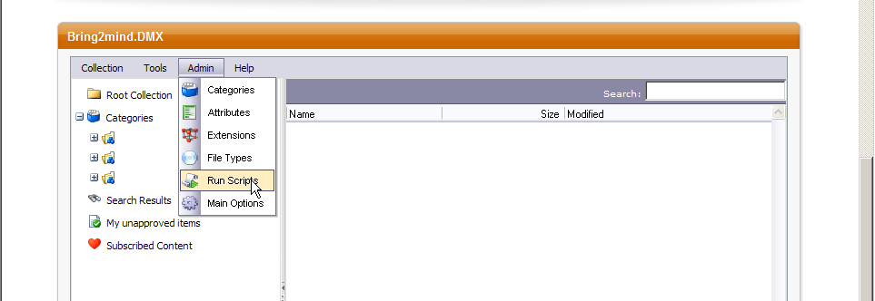
- You’ll see a dropdown with the various available scripts. You should be able to find one entitled DMX 3 to DMX 4 upgrade. Select this and click Run.
- You’ll also want to run the Reindex installation script to reindex all documents in the new search provider: Lucene.
You might encounter errors during the script. Keep a copy of the output of the screen just in case. It could help solve any issues later on.

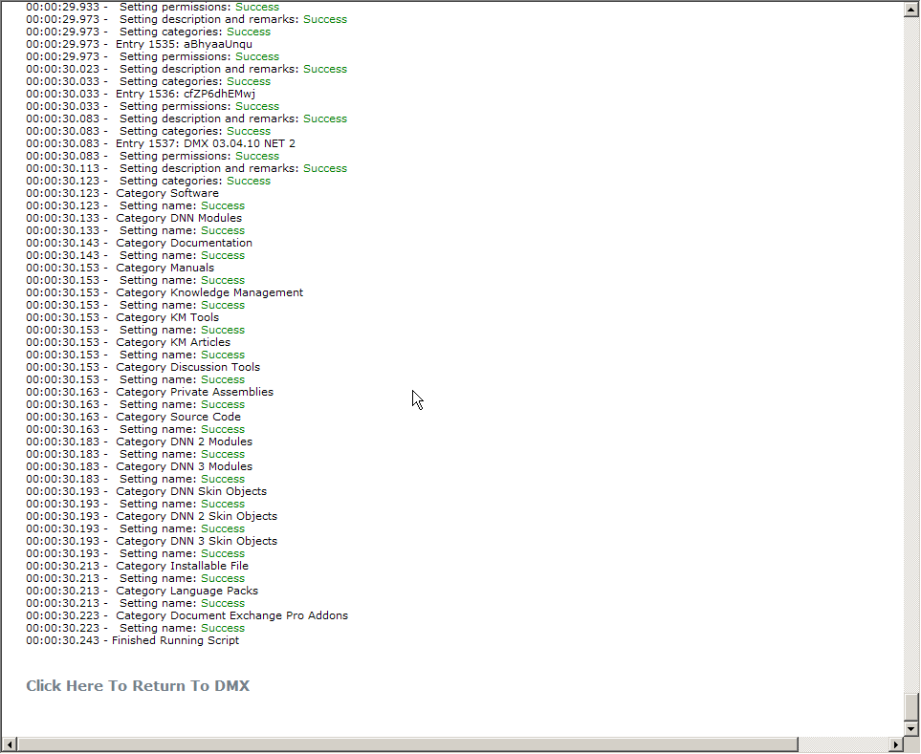

IIS tuning for WebDAV
If you plan to use WebDAV with DMX you’ll need to make changes to the way IIS handles incoming http requests. WebDAV (Web Distributed Authoring and Versioning) is a protocol that allows programs to open documents over http, edit them, and save them. Programs that implement this protocol include Microsoft Office, Microsoft Windows, and certain programs from other manufacturers like Autodesk. Consult the documentation of your application to see if it is capable of WebDAV.
Document Exchange is distributed with a WebDAV server component which means that client software can open and save documents directly from within DMX. Your DNN/DMX installation then behaves very much like a network share on the internet. In Windows this is referred to as ‘Web Folders’. Invariably the address starts with ‘http://’ just like a webpage. But the protocol implements a complementary set of ‘verbs’ (this is communicated in the request to the server) to do what it needs. Regular web traffic is mostly ‘GET’ and ‘POST’. In WebDAV we also see ‘OPTIONS’, ‘PROPFIND’ and ‘PUT’ to name a few.
IIS needs to be made aware of this incoming traffic and needs to direct it to the DMX WebDAV component. By default it will not and just reply ‘Unauthorized’ or ‘not found’ to the client.

Before we start: handlers and modules
An http handler is a piece of logic (a program or dll, e.g. ASP.NET managed code is handled by the so-called isapi handler) that handles a web request. An http module is a piece of logic that runs on every web request. So understand that all modules run on every request and only one handler runs. Both handlers and modules are defined in the web.config and are complemented by fixed IIS handlers and modules. The handler that runs is determined by going through this handler list. The first one that produces a hit gets the request. All subsequent defined handlers are ignored. A handler is chosen based on a path and one or more verbs. Both can be set to * as wildcard.
The elements necessary for WebDAV to function are a module to handle authentication (called WebDAVAuthenticationModule) and a handler to handle the webdav request (recognizable in the web.config by its reference to Bring2mind.DNN.Modules.DMX.WebDAV.DavHandler).

IIS 6
- Log in as administrator on your server
- Go to the IIS control panel and call up the properties of the web site of the installation
- Go to the ‘Home Directory’ tab
- Go to ‘Configuration …’
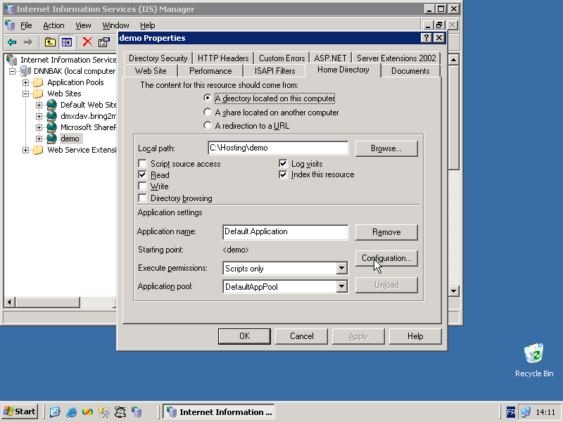
- Double click on the ‘.axd’ extension mapping in the ‘Application Extensions’ list
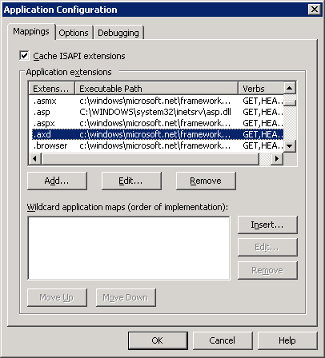
- Change the Verbs list in the ‘Limit to:’ text box to read:
GET,HEAD,PUT,OPTIONS,PROPFIND,PROPPATCH,COPY,MOVE,DELETE,MKCOL,LOCK,UNLOCK,DEBUG
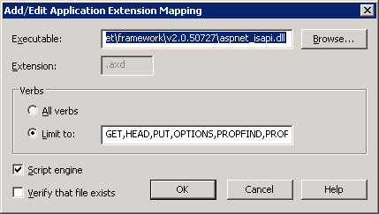
- Copy the text under ‘Executable’ to the clipboard (in .net 2 it should be c:\windows\microsoft.net\framework\v2.0.50727\aspnet_isapi.dll)
- Under ‘Wildcard application maps’ click ‘Insert…’
- In the dialog fill in the clipboard text under Executable and uncheck ‘Verfiy that file exists’. Click OK.
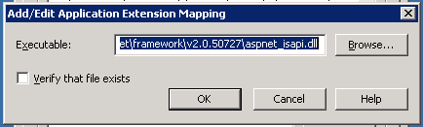
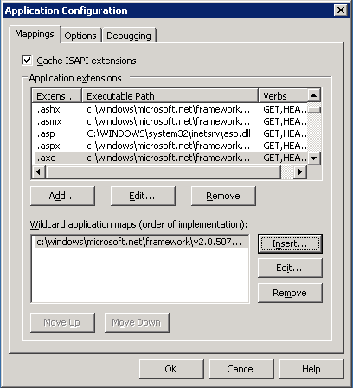
- Make sure you leave the rest untouched (check illustration for final result)
- Click OK three times to exit the Application Configuration and website properties
- Go to the ‘Web Service Extensions’ node of your IIS panel
- Make sure WebDAV is ‘Prohibited’. DMX integrates its own WebDAV, the Windows WebDAV conflicts with this.
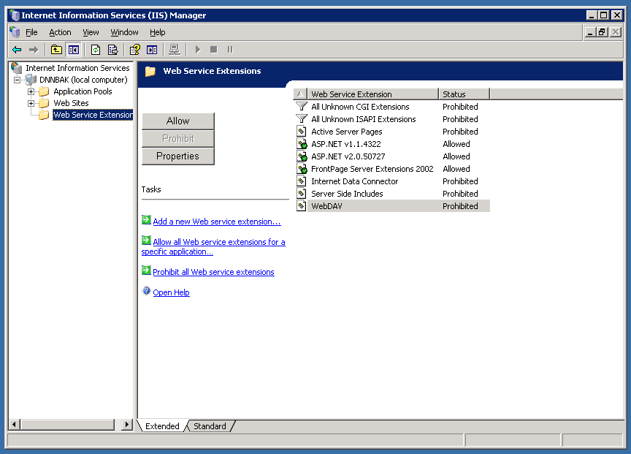
Now you should be set to use WebDAV in your DNN/DMX installation.

IIS 7
The changes necessary to get WebDAV to work under IIS 7 are similar to IIS 6. The screens look very different, though. IIS 7 now shows all modules and handlers whether from IIS or web.config. The origin is shown in the column Entry Type. All changes will be saved in the web.config (this is the step forward in IIS7, if you now move the installation to another server the settings will migrate with it).
- Open your browser and go to your DNN/DMX site, log in as host and go to a DMX page. From DMX’s menu select Admin > Web.Config
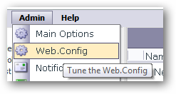
- Make sure the WebDAV is enabled under IIS7
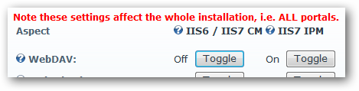
- Open IIS Manager, open your DNN web site, and open ‘Handler Mappings’ under the IIS area
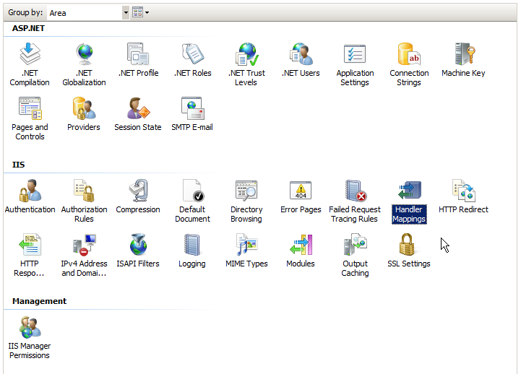
- If present delete Microsoft’s IIS WebDAV handler
- Switch to the Ordered List
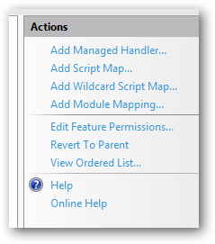
- Check the order of the handlers.
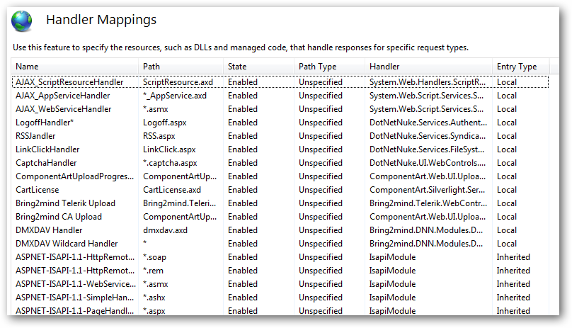
Pay close attention to the DMXDAV handlers. The dmxdav.axd must not be caught by a *.axd handler above it. Note that the * handler only catches the OPTIONS and PROPFIND verbs so most traffic will not be caught by it.

Debugging WebDAV issues
Unfortunately the use of WebDAV is very fragile because it depends not just on the server being correctly configured but also the client software must play nice. Due to the complex nature and the fact that different software versions can change the way they implement the protocol, it is a good to be able to debug WebDAV issues yourself.

Step 1: Server or Client
The first thing to determine is if the error is caused by a badly configured server or client. The easiest is to just try a number of different clients. Try using ‘Open in Windows Explorer’ on a folder or ‘Open in Word’ directly on a Word file. The first uses the Windows Web Forms client, the second uses MS Word (these are not the same clients). Similarly you can try a different machine. Also you can download third party WebDAV clients such as Webdrive (www.webdrive.com). If any of these clients succeeds in getting through chances are you’ve set up the server correctly.

Step 2: Examining the Traffic
A tool I often use to debug issues with WebDAV is a packet sniffer, i.e. a piece of software that examines the traffic between the client and server. This is not for the faint of heart, but there are tools that make it quite simple. My favorite is Fiddler (www.fiddler2.com) which is free. Read more about using this to debug WebDAV traffic here:
http://www.bring2mind.net/Company/News/tabid/155/EntryId/64/How-to-debug-your-DMX-WebDAV-using-Fiddler.aspx

License and Activation
Document Exchange needs to be activated to work. This is not necessary if you address the module locally (i.e. through http://localhost/etc). The activation mechanism supports trial licenses (and hence activation). You can activate the module for 30 days without purchase. Note that the module does not become fully crippled when not activated. Instead all upload/edit actions will be disallowed. Download of existing content is still possible. This change assures that you now have time to contact us if something goes wrong with your installation and the module refuses to activate for whatever reason. During this period users can at least still access content.
Note that a license is something different than an activation. In the most common scenario you buy a license to use DMX on a single DNN installation. In most cases, customers will also want to use the software in a staging environment as well as their production environment. Keeping a running mirror copy of your production site for testing is good practice, and we do not require you to purchase extra licenses for this. So we sell you the right to use the software on one production DNN installation but we allow you to use it on your staging site as well. Because DMX needs to be activated to work, this means you’ll need to activate twice. So you have one license and two activations. Note that if for some reason you need an extra activation you can always contact us. Check out more details about licensing here:
http://www.bring2mind.net/DocumentExchange/Licensing/tabid/182/Default.aspx
During activation your DMX will get an activation key from the Bring2mind server. This server will identify the installation using a generated ‘server key’. This key contains information about the DNN installation as well as your license details. These details consist of an email address and an invoice code. When you purchase DMX, these details should be emailed to you. If you’re trying out DMX then you don’t need these details right now.
To activate DMX you should follow these steps:
- Log in as host in your DNN installation
- Go to a place where DMX is instantiated in the portal or add it to a page now
- Under the module’s menu you should find a menu item ‘License’. Select this
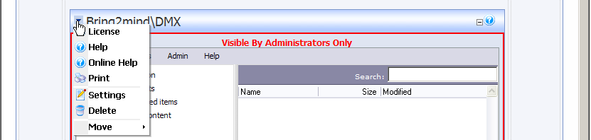
- You should now be directed to the activation screen. You’ll see the current state of your license.
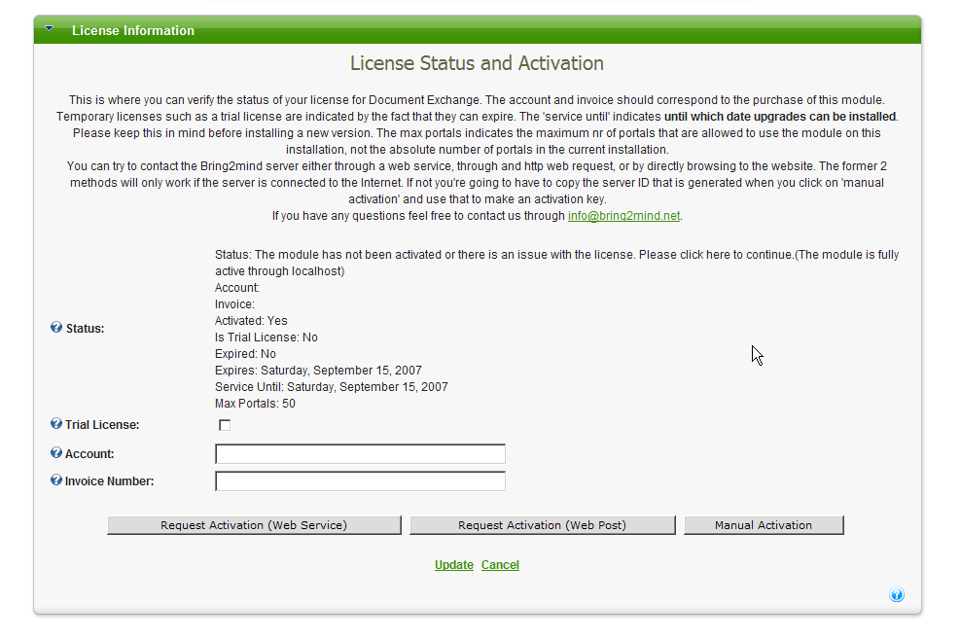
- Either fill in the account (email address) and invoice nr OR select ‘Trial license’ (the latter will disable the account/invoice text boxes).
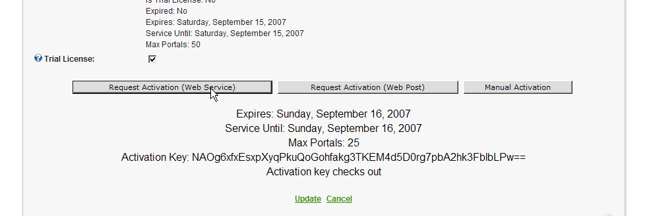
- You can request activation through a web service or by web request. Try the first and if it fails, try the second. If any one is successful you should see a notification in your screen to that effect. If not there is nothing to worry about as we can also activate manually. Click ‘Request Activation’
- If you’ve successfully activated you should see a screen with the license details and you can click ‘Update’. The following steps do not concern you.
- If you’ve not been able to activate automatically then click ‘Manual Activation’. You’ll see two text boxes appear. One with a Server ID and one with the Activation Key (the current active one). You’ll also see a hyperlink to www.bring2mind.net. Please use this hyperlink to go to Bring2mind.net. You can also copy this hyperlink and use another (internet accessing) PC to go to this page.
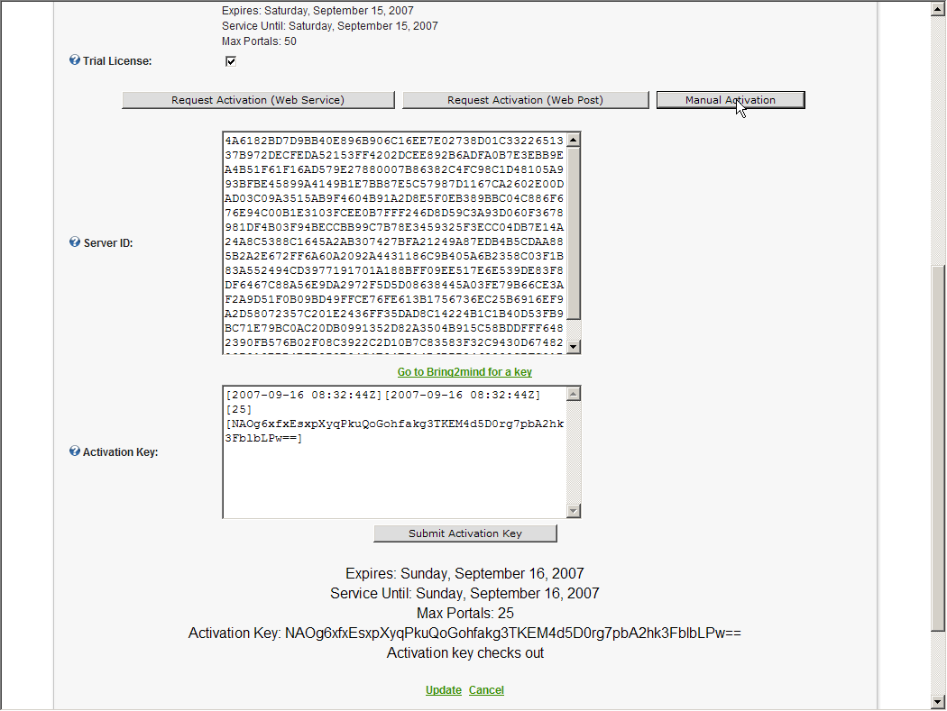
- You’ll see a web page where you need to select the module and enter the ‘server key’ that you can copy from the activation screen. Use this page to generate a valid activation key.
- Copy the key from the bring2mind.net page to your DMX license screen in the Activation Key box and click ‘Submit activation key’. A message will appear at the bottom of the screen to confirm the activation.
- You should now have activated the module and you can click ‘Update’ to save the license and go back to your installation.
Note that the activation is bound to the DNN installation. You should be able to upgrade or move server without breaking this. If the module refuses to activate and you feel it should, please don’t hesitate to contact us.

Debugging Activation
The activation details are stored in portals/_default/DMXLicense.Config. This is a straightforward XML file. Make sure that DNN has access to this file when activating DMX. There have been cases where customers have moved their installation from one server to another and forgot to correctly configure permissions on the physical files in the installation. Make sure the worker process identity (by default NETWORK SERVICE) has full access to this file so it can change it.
If all else fails, delete the file and activate again. The licensing server remembers your installation and will not reduce the activation count.

Uninstalling
In the event you wish to uninstall the module you MUST do the following:
- Log into your server and open the web.config
- Either:
a. Remove the entries in httpModules and httpHandlers that contain the word Bring2mind (see the web.config extract above in Installation Checking), or
b. Go to the web.config edit screen of DMX (DMX Admin menu, log in as host) and click the remove buttons to make sure all elements are removed from the web.config that are part of the module.
- Log in as host in your DNN
- Go to ‘Module Definitions’ and click on the pencil icon next to Document Exchange Professional.
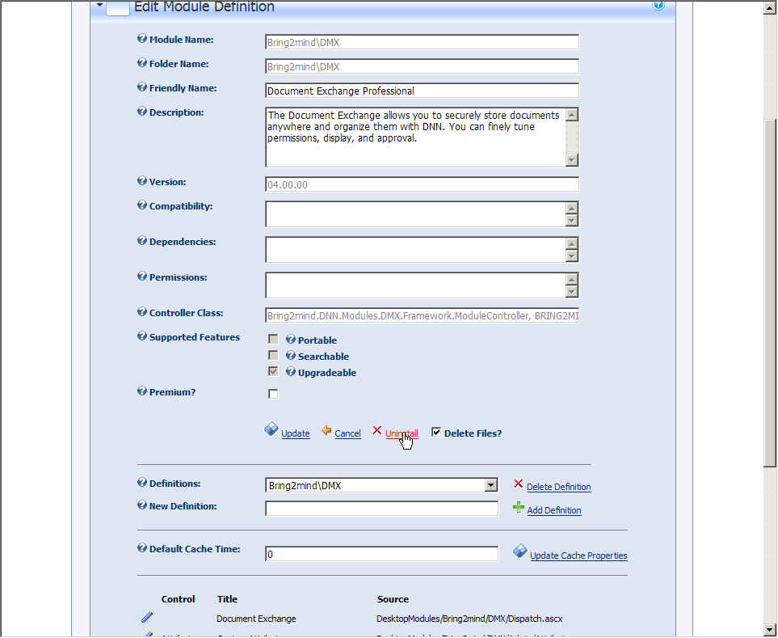
- Select ‘Delete Files’ and click Uninstall
- Manually delete the various DesktopModules/Portal/[PortalId]/DMX directories that have been used to save files
In the event you cannot remove the installation using the DNN interface for whatever reason, here is:

How to remove DMX from your installation by hand
- Log into your server and open the web.config
- the entries in httpModules and httpHandlers that contain the word Bring2mind (see the web.config extract above in Installation Checking)
- Delete the DesktopModules/Bring2mind/DMX directory
- Manually delete the various DesktopModules/Portal/[PortalId]/DMX directories that have been used to save files
- Open your SQL Management Studio
- Delete all procedures and tables prefixed with DMX_. Note you might have to retry a few times with the tables to get them all deleted.
- Go to DesktopModules and find the record where ‘FriendlyName’ is ‘Document Exchange Professional’. Delete this record.
The last action should remove both the definition of the module and any instances in the site. You should have a clean installation again after this procedure.

