DMX: Getting Started
Peter Donker, January 2008

Important: DMX content architecture
At this point it’s important you get familiar with the way DMX organizes its contents. In this part I’d like to discuss the consequences of a design decision that was made when DMX was first conceived. The decision was this: DMX modules act as ‘windows’ to an underlying ‘Portal-Wide’ tree of items. In other words: the data you enter in DMX is shared across the portal. And: there is only ONE tree per portal. This means if you instantiate multiple DMX modules in your portal they all display the same content for a given user. This would not be very useful if it wasn’t for the fact that we can set the ‘root’ collection to point to any collection of the underlying tree for every one of those DMX instances. This way the DMX instances resemble more ‘virtual drives’ in a windows network. Now we can add DMX instances for particular purposes in our portal while preserving the ability to share content across the portal. You can find these settings under the module’s settings. Below is an illustration of this design.
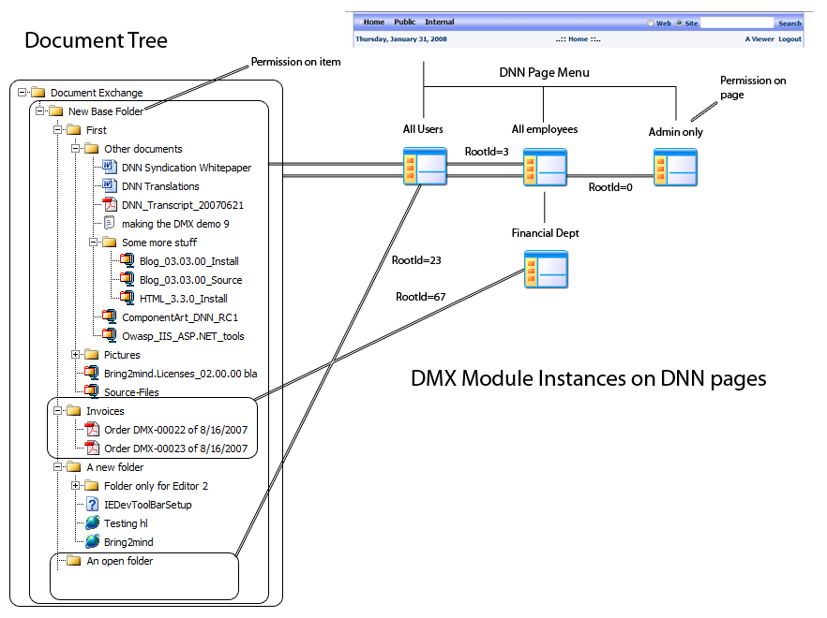
Figure 1. Overall DMX Content Architecture
You can see the DMX instance on the page that is visible to ‘All Users’ points to ‘An open folder’ and the instance for the ‘Financial Dept’ starts at ‘Invoices’. Note that there is an instance for Administrators that points to the very top of the tree.
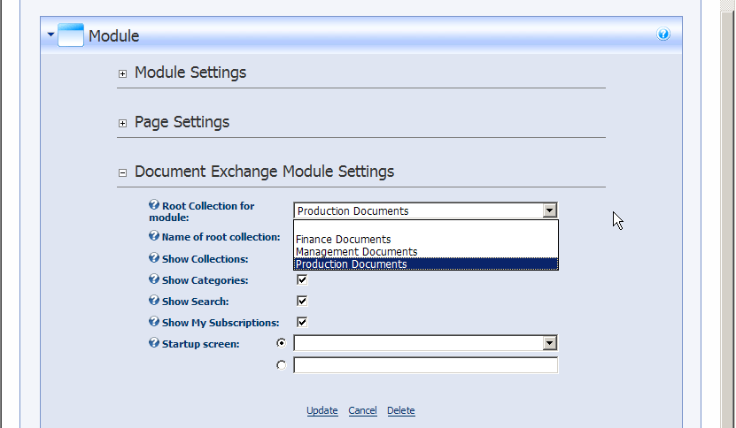
Figure 2. Specifying the root node in a DMX instance (Module settings)
Note that although DMX will show you the document tree starting at the node specified, it does not mean you cannot access other material through that DMX instance. DMX also shows ‘categories’ for example and documents available to the user will show up regardless of whether they are in the subtree of that DMX instance. In everyday use the permissions in DMX will follow the lines of the folders so this will not be too confusing (so content visible to ‘All Users’ will only be stored underneath ‘An open folder’ or below and content only for ‘Financial Dept’ will be kept under ‘Invoices’). See more about this in the paragraph on ‘permissions’ below.

The absolute root
There is such a thing as the absolute root collection which is the root of the underlying document tree. It has an EntryId (the unique identifier of content in DMX) of 0. It is a special case as, contrary to all other items in the document tree, this one has no record in the database. It is just a placeholder to let DMX know: start here. As a consequence it does not have the same metadata as other items like permissions. In DMX 3 this virtual collection took the permissions from the module. Because permissions have been enhanced in DMX 4, this is no longer possible. Instead, the absolute root collection is now only available for administrators.

Permissions: who can see what?
This brings us to permissions. It is important to keep in mind that every item in DMX has its own permission set. This means that regardless of which DMX instance you’re watching, you’ll still only see what you’re allowed to see. The various DMX instances are just to help you organize content, they don’t influence permissions. Well, almost. The VIEW permissions on a module are laid over the DMX permissions if you like. If you have the permission to see DMX content but you don’t have permission to see the DMX module, you still won’t be able to access the content because you actually can’t see the module.
This needs a little more thorough examination. You can have access to item X in the document exchange but you need to see the module somewhere in order for you to access this. Lets take the illustration above and imagine there was no ‘All Users’ instance. Now lets assume you are a regular employee (i.e. not ‘Financial Dept’). If Joe at Finance was to send you a link to ‘Order DMX-00022 of 8/16/2007’ you would never be able to see or download it because the permissions on this document are such that DMX will prevent you at all times to access it. If he sent you a link to ‘Source-Files’ however, you are permitted by DMX to see it. But the link includes the url to the page where Joe was viewing this, e.g.
http://ourhost/Internal/Financial/Tabid/234/Default.aspx?EntryId=56
This url would take you to the page in DNN with ID 234 which is not viewable to you. Ah, now DNN will override the permissions and deny you to see this document. Instead you’d need to go to your own page and find it there.
For this reason DMX 4 uses a common DMX instance that is visible to the largest group (i.e. ‘All Users’ or ‘Registered Users’ if you have no public content). It’s good practice to have one of these in your portal. On the ‘main options’ admin screen you select this module and every link that is produced in DMX will point to that instance. That way you are assured you can send someone a link to content that he/she will always be able to click and see.

Host permissions: a note of caution
DMX does its best to avoid unauthorized access. Many aspects of its functioning are bound to users and roles. There is an anomaly in DNN that is not widely known: the host does not belong to any portal role by default. This means the host is not known as an ‘Administrator’. Instead, DNN relies upon developers to make workarounds for this. Unfortunately in the case of DMX this would lead to a good deal of extra code that introduces new vulnerabilities. Because it was seen as too risky, the host does not have rights to edit/add data in DMX without being granted a role in DNN. You can add a role to the host account in the user/role management of DNN. You should consider doing this to avoid any frustrations. Note that the above does not apply to SuperUser accounts that were created in the portal. They already have portal roles associated to them. Finally: if you are having trouble adding stuff to the absolute root of your installation, verify that the Admin account you’re using actually belongs to the ‘Administrators’ role that you set in the portal settings. There have been support calls where this was not the case.

Best practice setting up DMX
If you’ve read the above and it has sunk in the following should seem logical. But just for completeness what follows is what we consider ‘best practice’ in using DMX.
- Create a page visible for the administrators only and add DMX to it. Leave the root collection of this instance untouched. This instance is meant to manage the whole document tree.
- Make a plan for the various instances since you can set up DMX instances as windows to the underlying document tree. For example, if you have a software company like me, you want a ‘downloads’ section, and maybe an instance on a page for customers only.
- For each application add collections to the absolute root in your installation. Make sure you set permissions correctly on these first collections. In my example I’ll give the ‘downloads’ collection the permission of View for registered users for instance, and edit and add by administrators and employees.
- Add the DMX instances on the pages where you need them. Make sure the right roles have View access to the page or else they won’t see anything.
- Set the root collection in the DMX instance to the relevant collection under the module’s settings.
This should give you a document management system with a maximum of control and flexibility. Note that in a particular DMX instance you cannot edit the root collection, whether it is the absolute root or not. Permissions are by default inherited from parent to child so when someone adds a file the permissions are inherited from the folder in which it is placed. If there is a role selected for approval then the items will first need to be approved before it is visible to others.
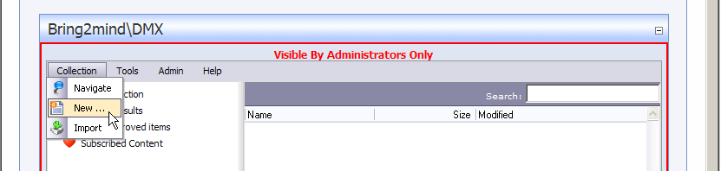
Figure 3. Add a new item to the root
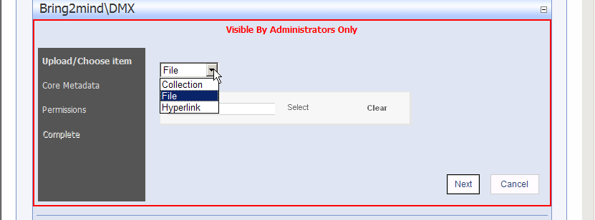
Figure 4. Select 'Folder'
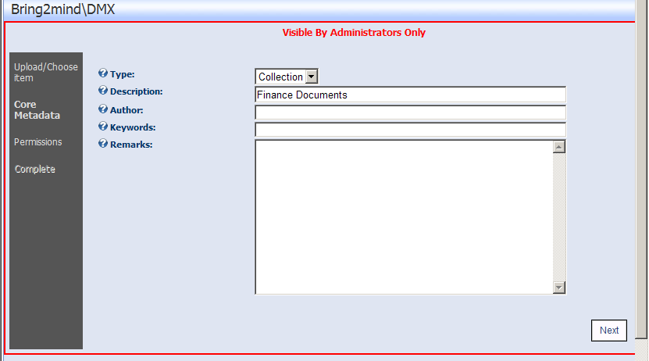
Figure 5. Give it a meaningful name
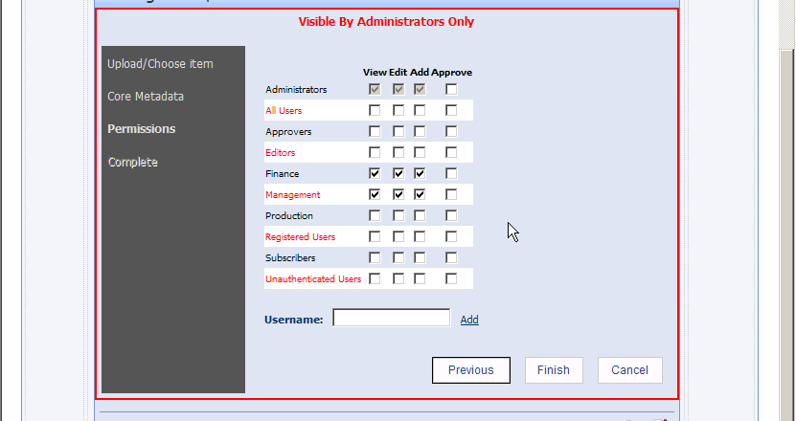
Figure 6. Important: set permissions correctly

Continuing your setup
You can now continue to set up categories and any subfolders that you may need. Refer to other documentation for explanation about other aspects of DMX.

New Portal: Important!
A script needs to be run to initialize a new portal. This is done automatically when you first instantiate a DMX within the portal. You can verify whether it has run by checking the DMX_Extensions table and verifying there are records in that table where PortalID = the id of the new portal you’re creating.

